**AUTHENTICATION**

**Endpoint:** [**https://monet.test/api/register**](https://monet.test/api/register)

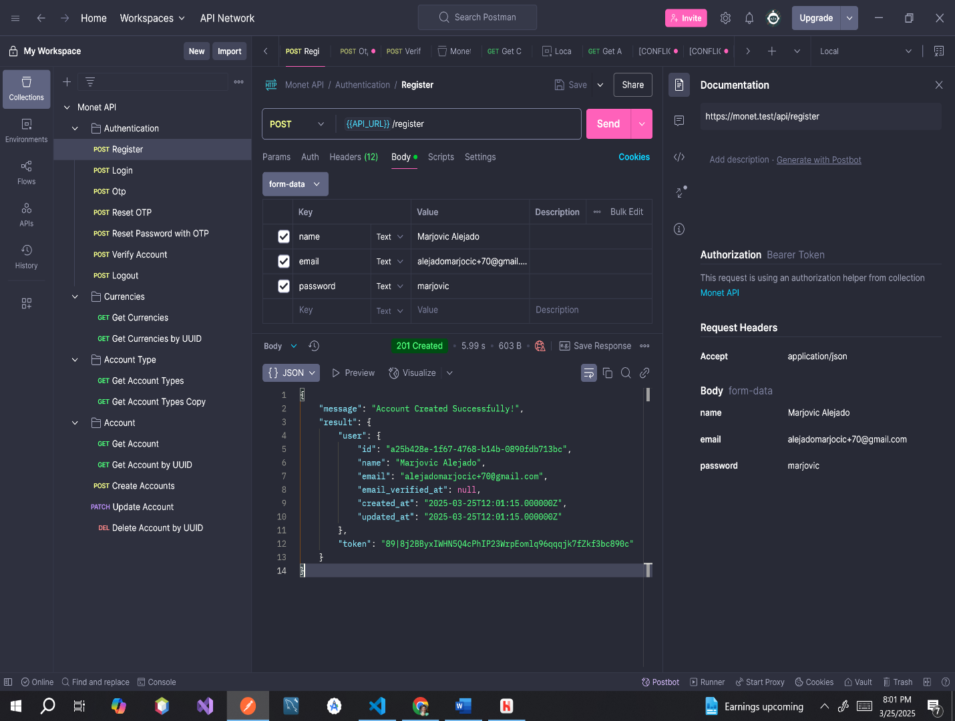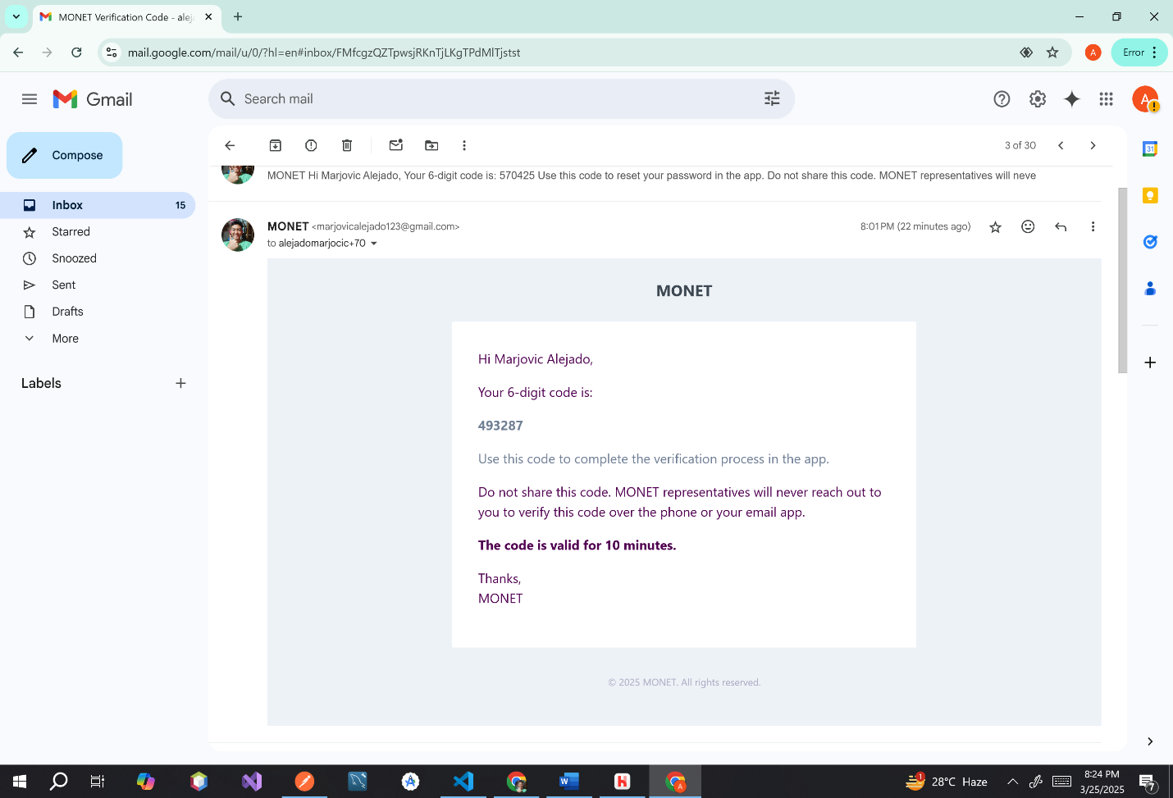

**ERROR MESSAGES**

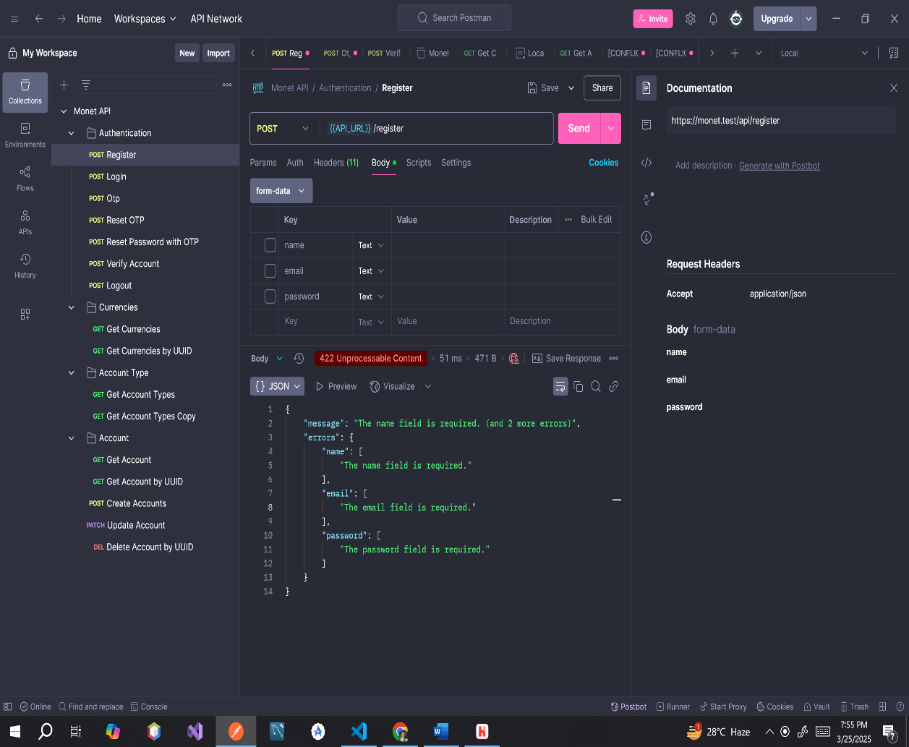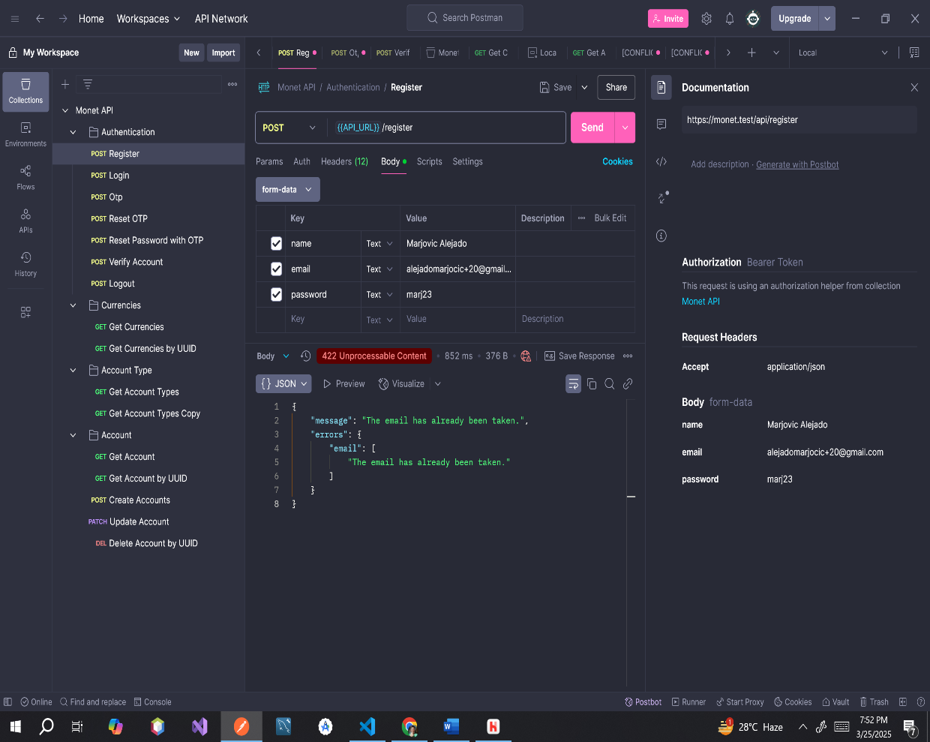**Endpoint:** [**https://monet.test/api/login**](https://monet.test/api/login) 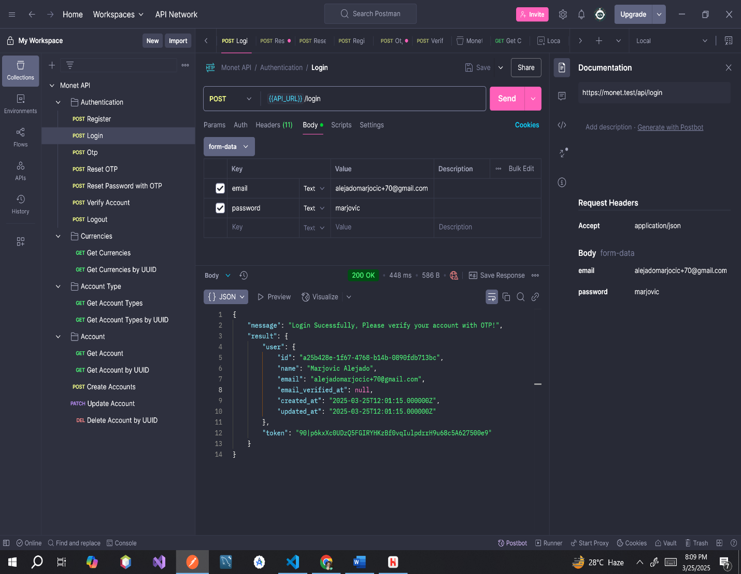

**ERROR MESSAGES**

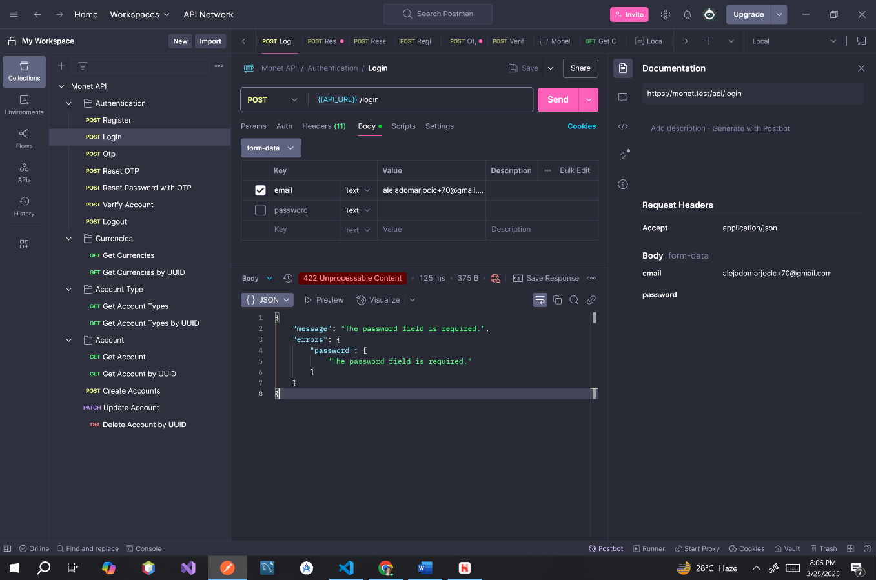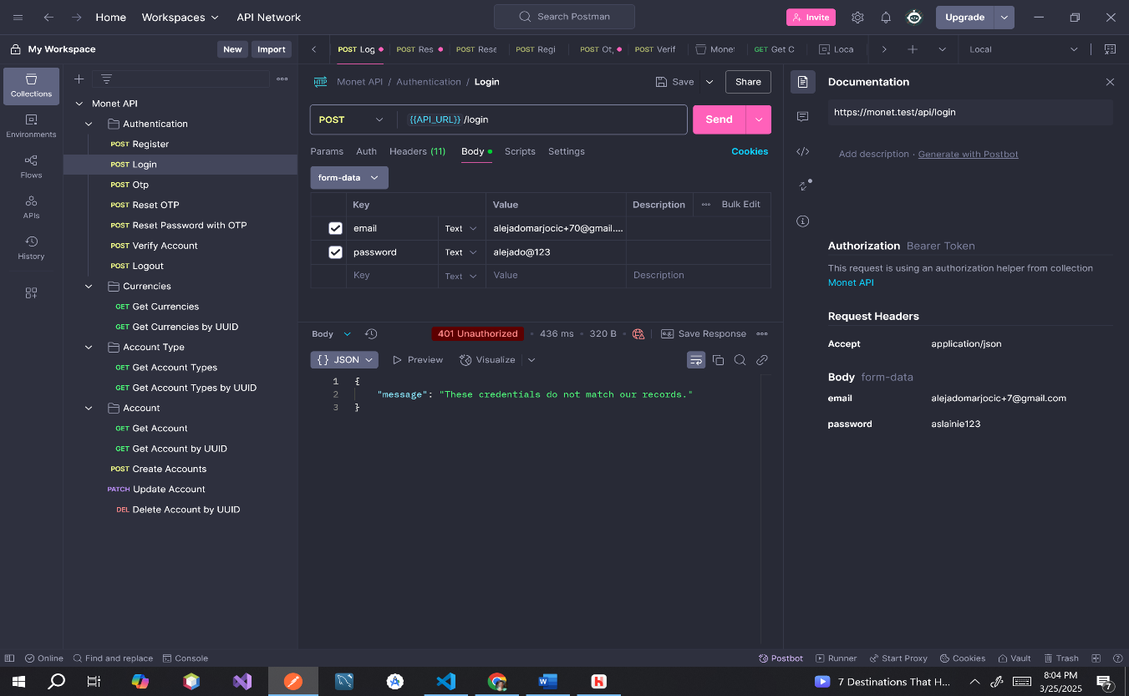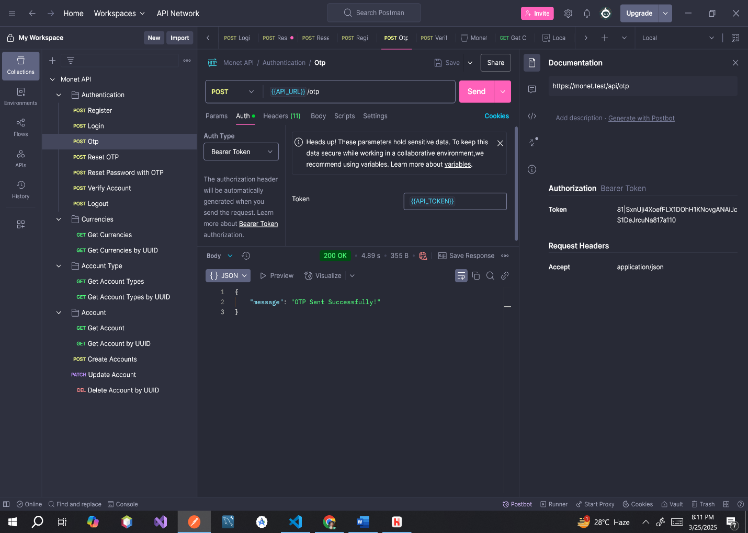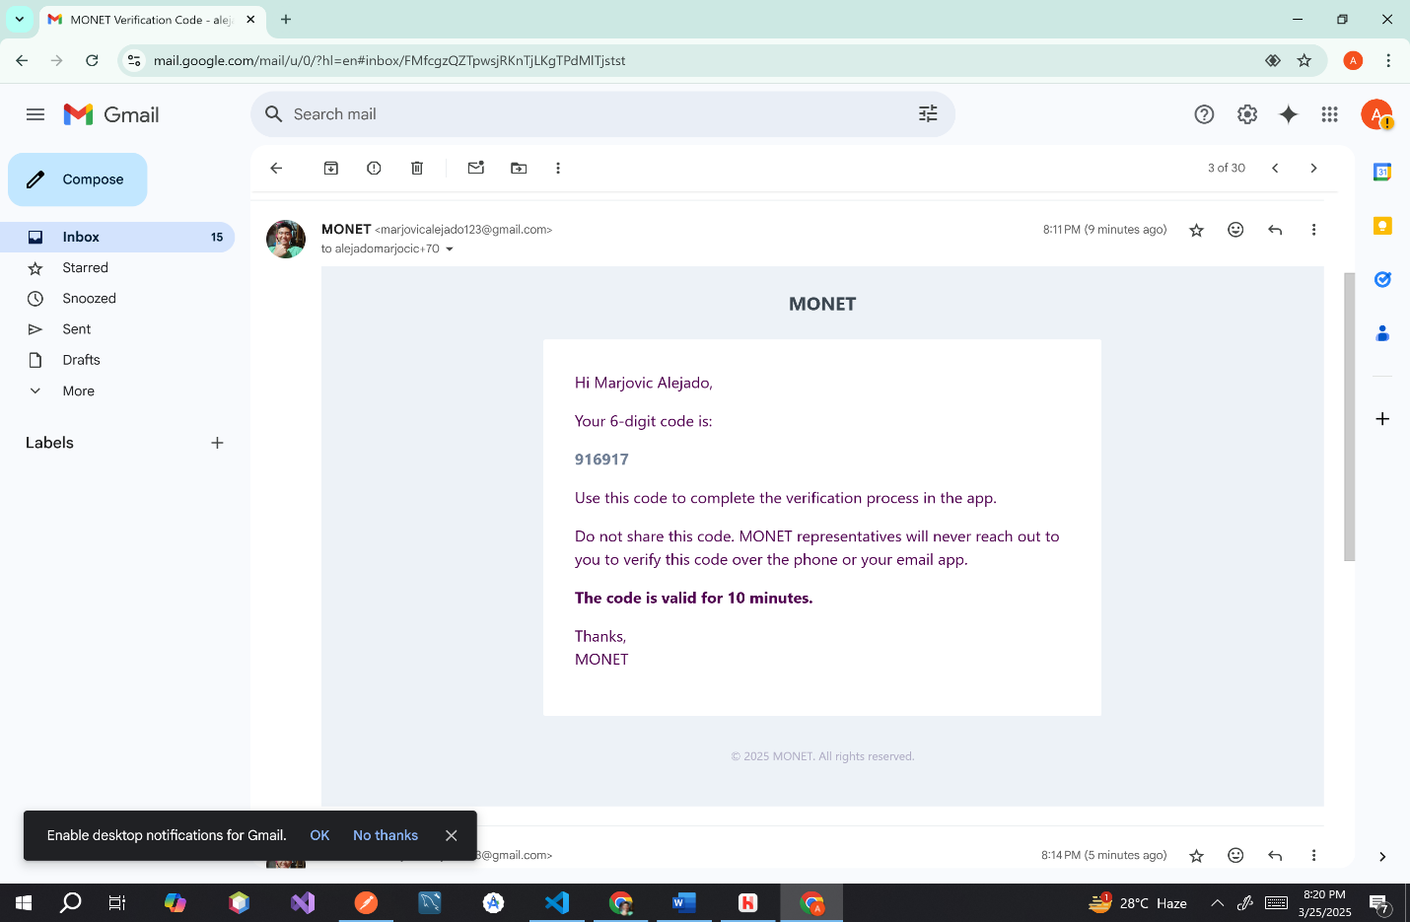**Endpoint:** [**https://monet.test/api/otp**](https://monet.test/api/otp)

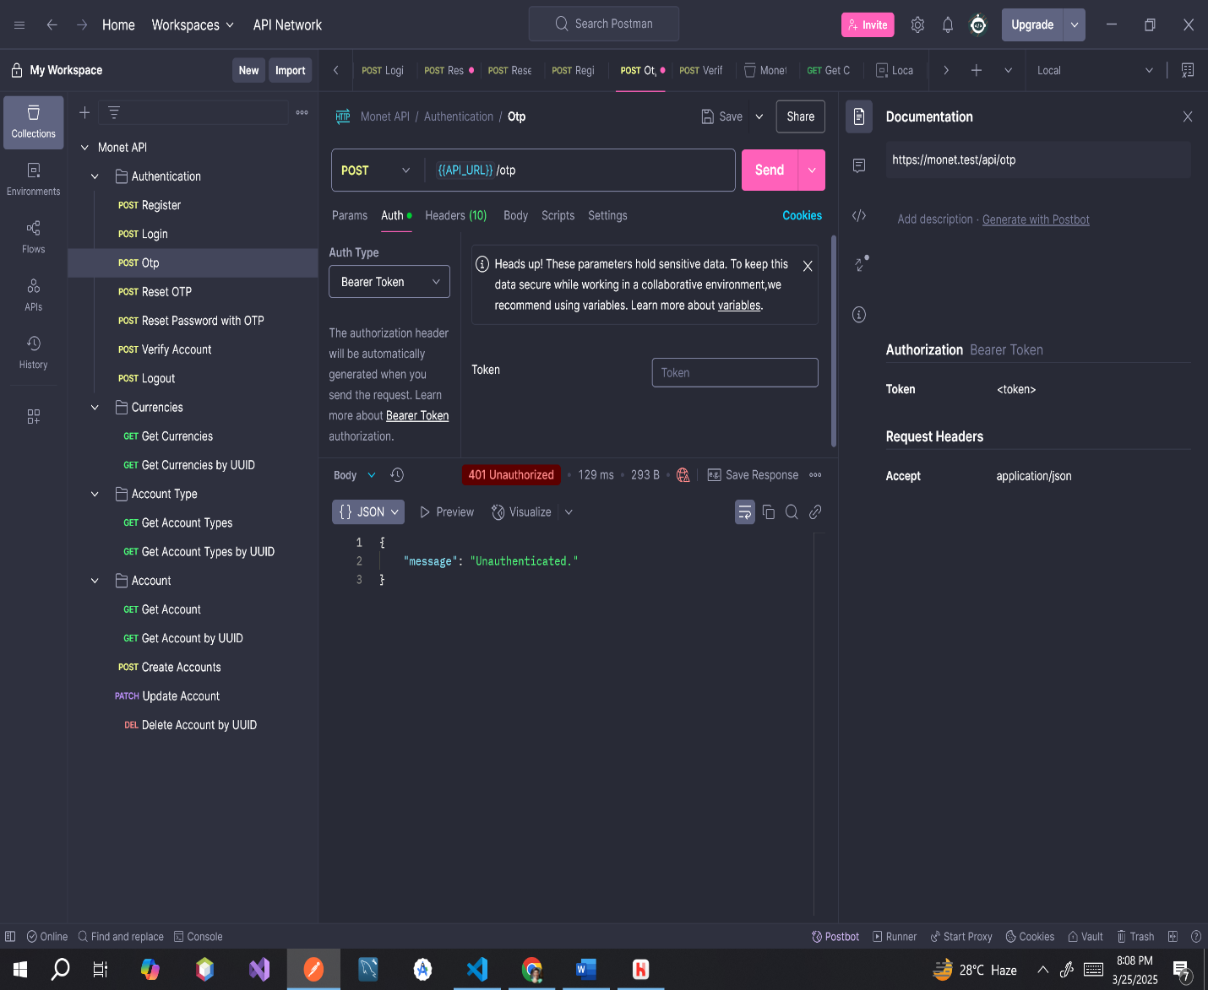**ERROR MESSAGE**

**Endpoint:** [**https://monet.test/api/verify**](https://monet.test/api/verify)

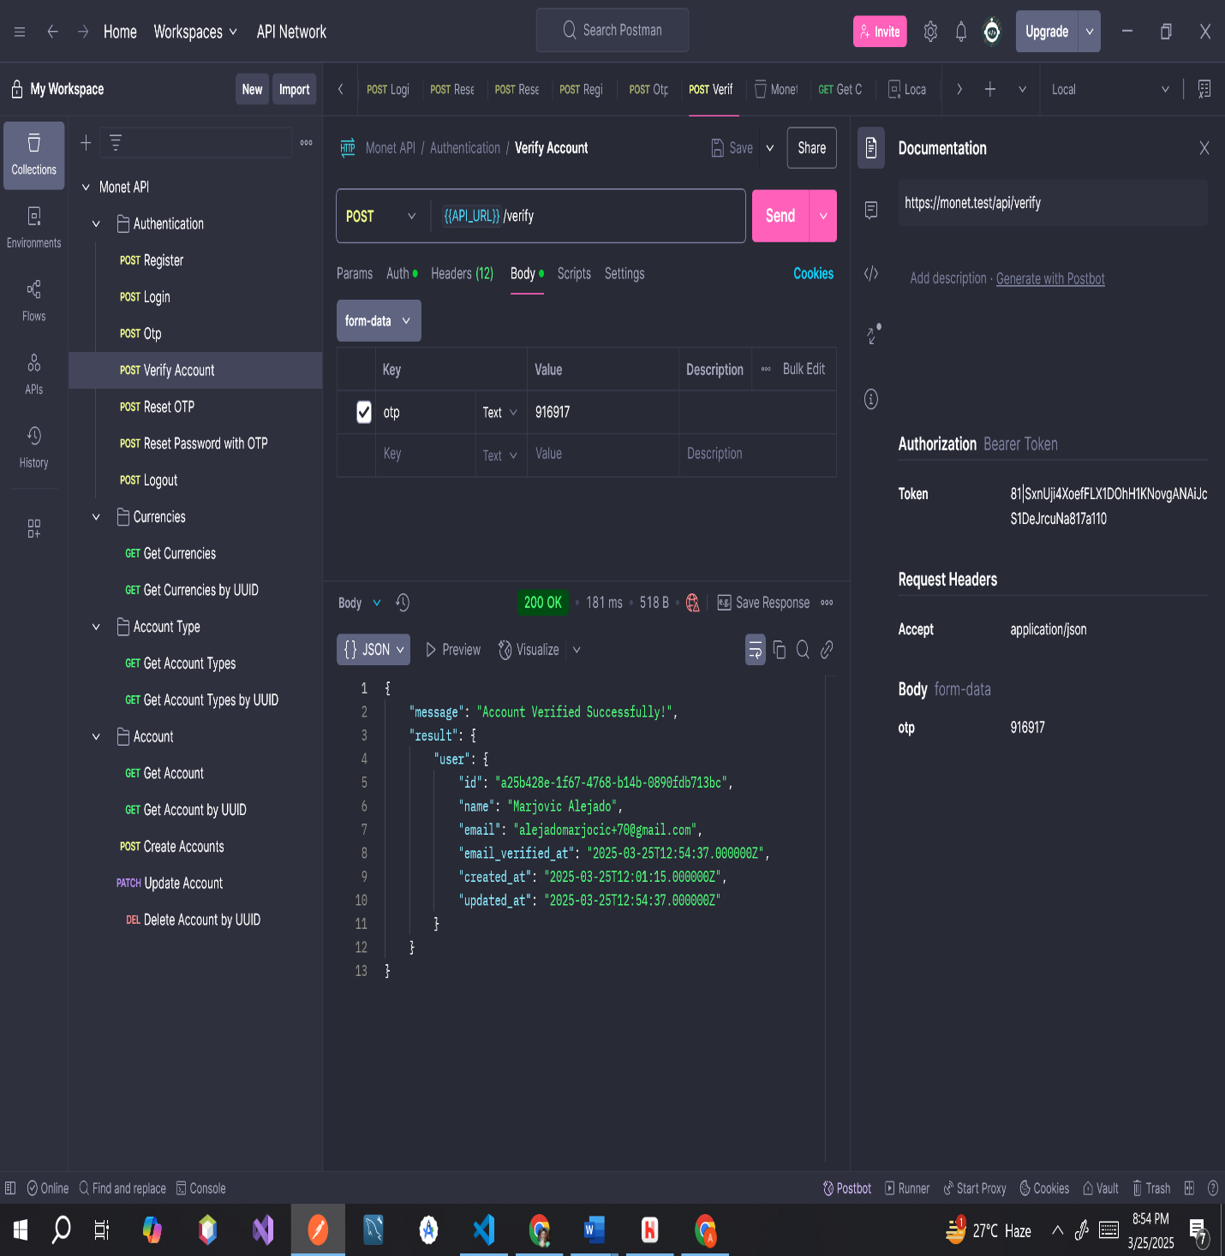

**ERROR MESSAGES**

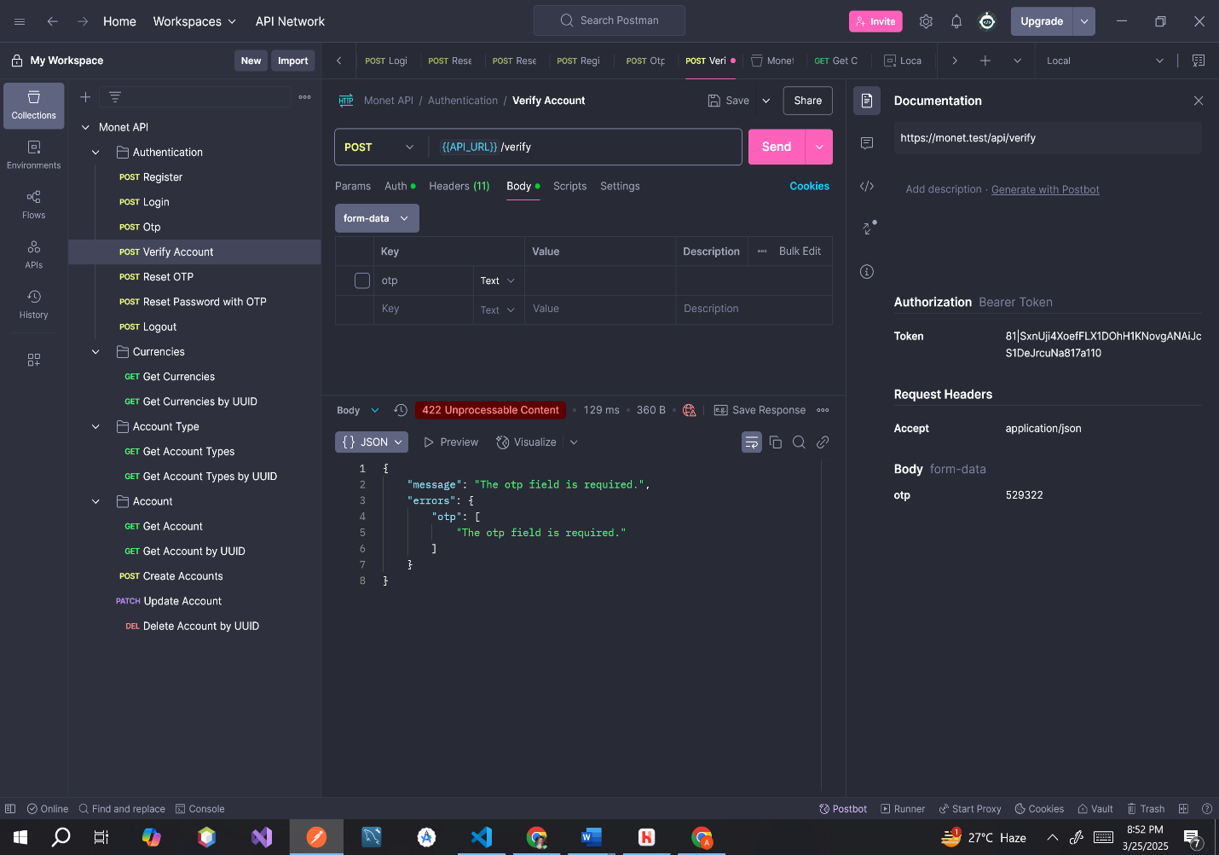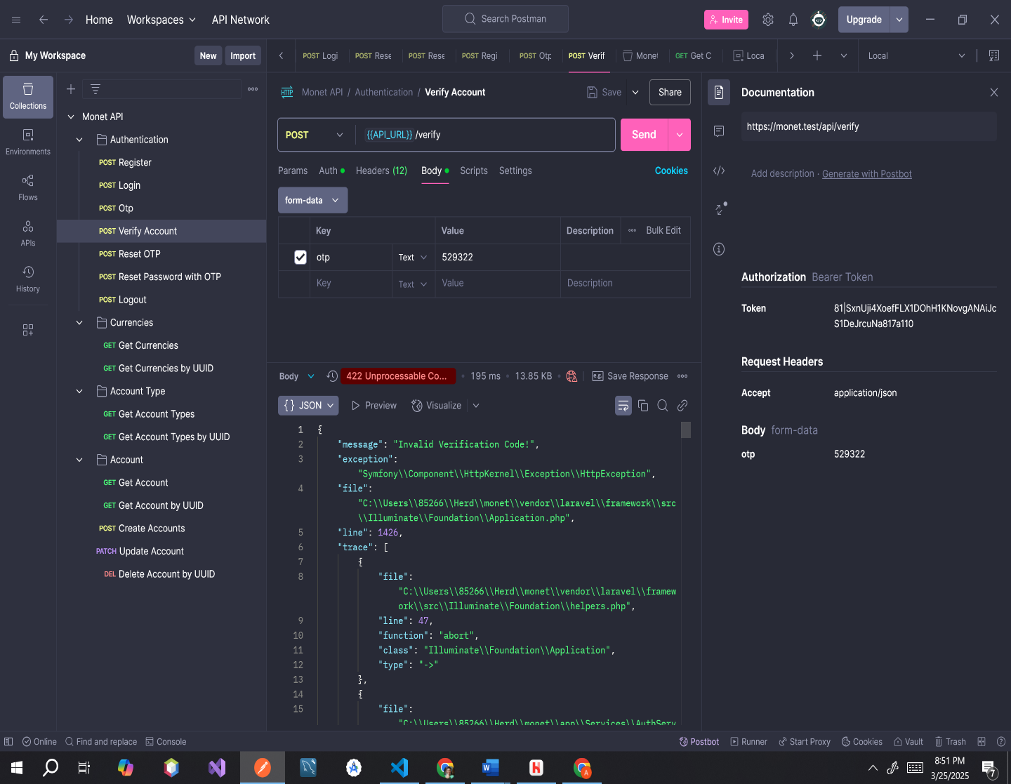

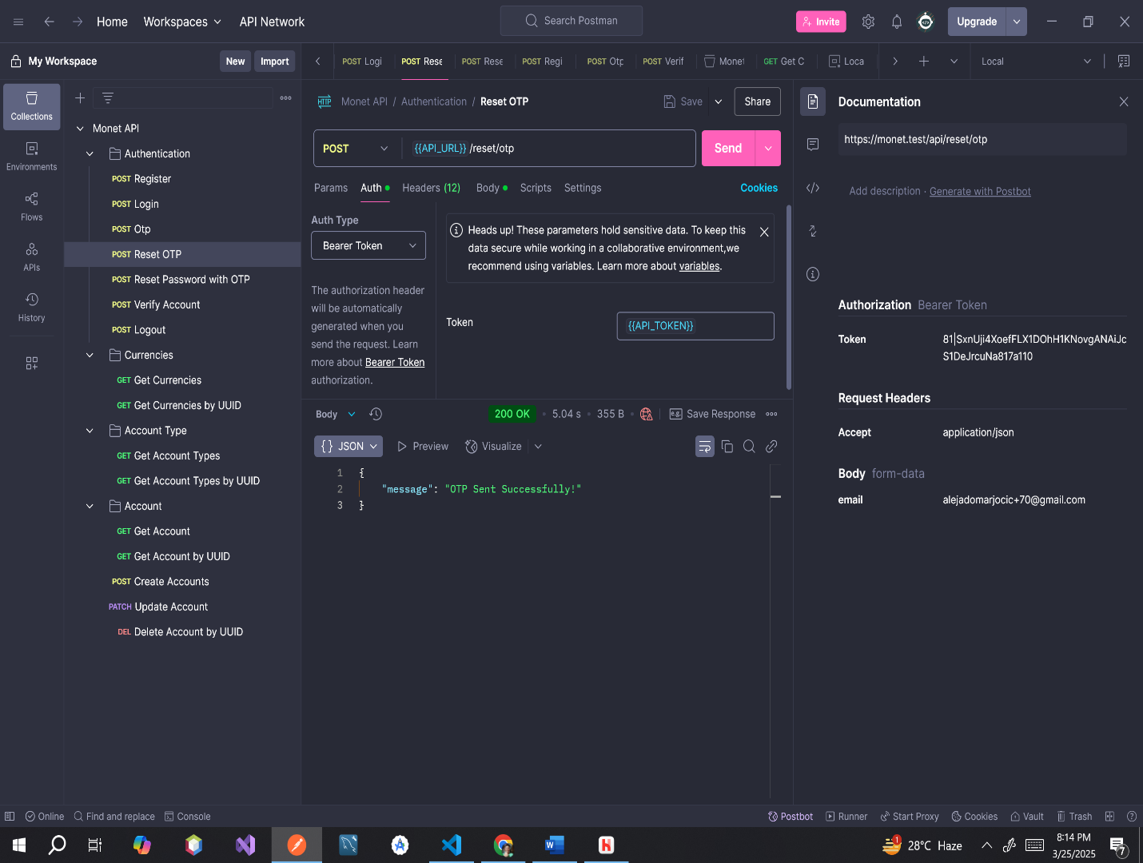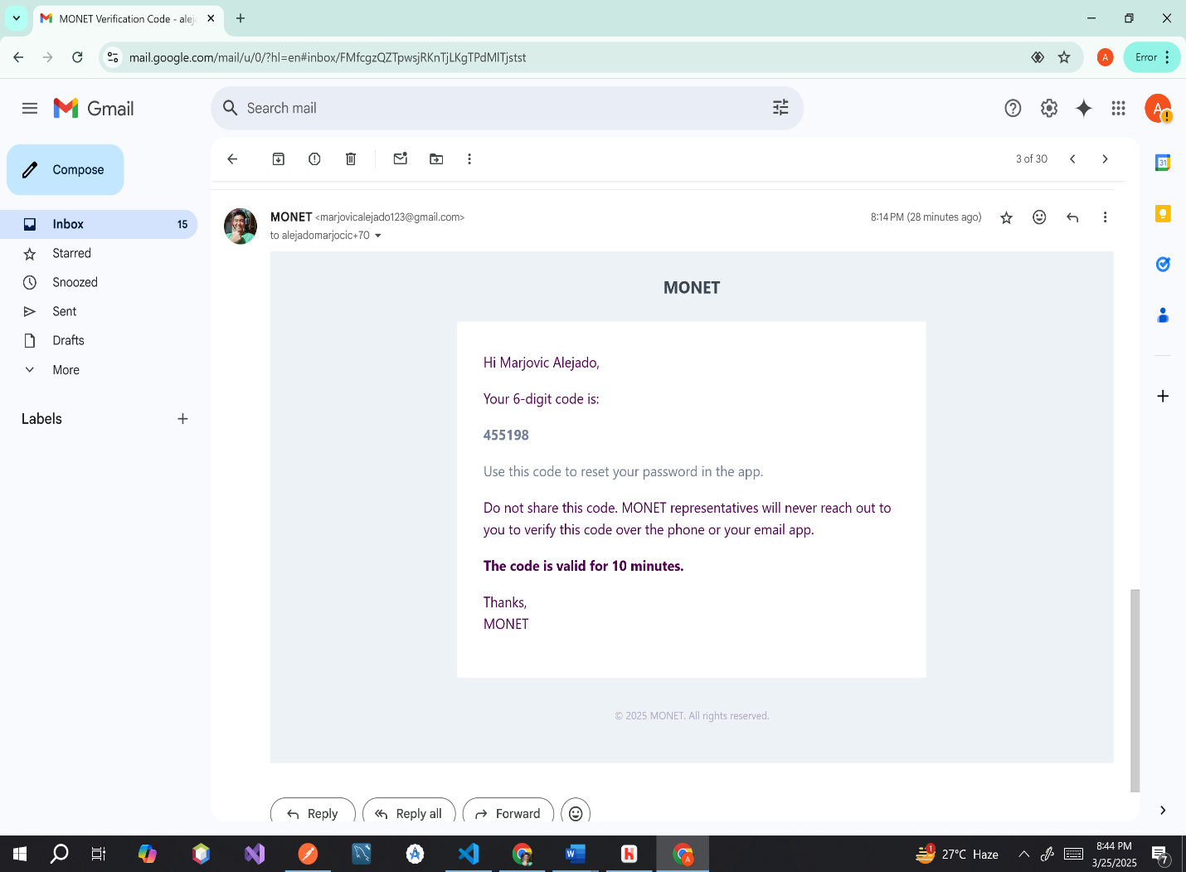**Endpoint:** [**https://monet.test/api/reset/otp**](https://monet.test/api/reset/otp)

**ERROR MESSAGE**

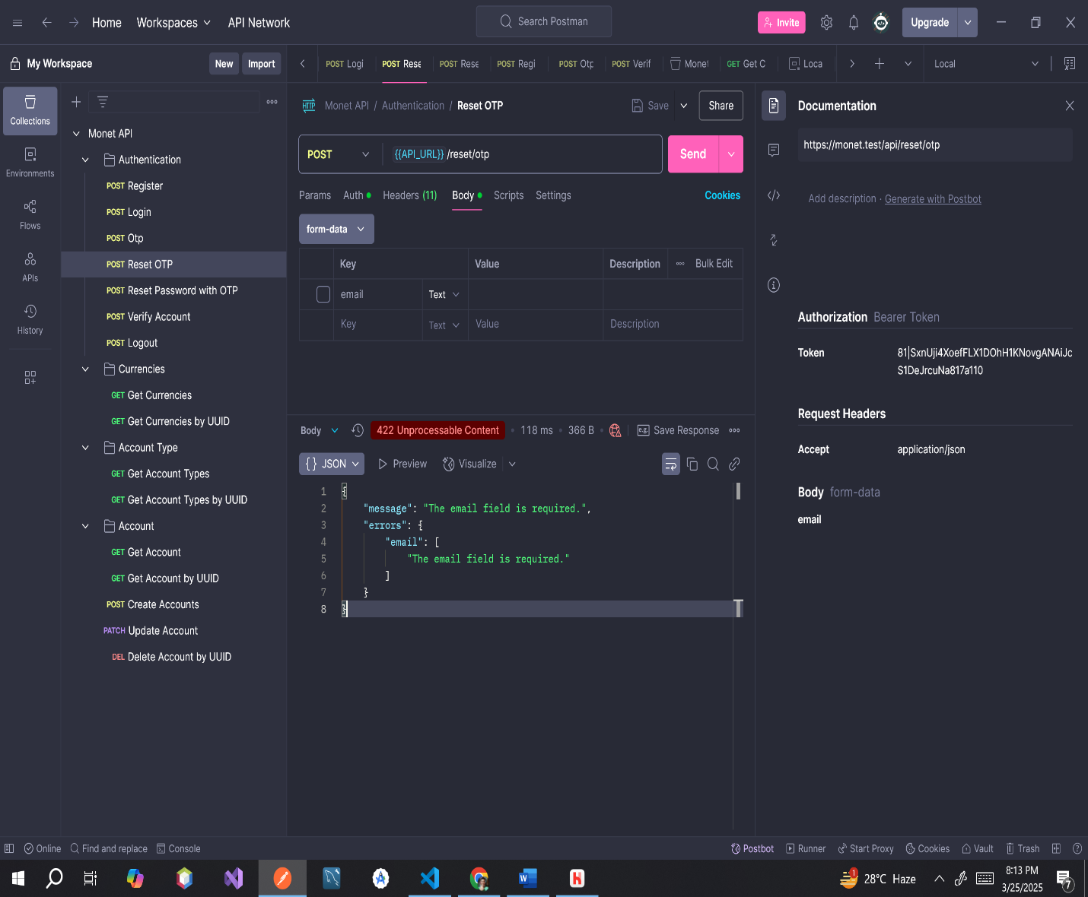

**Endpoint:** [**https://monet.test/api/reset/password**](https://monet.test/api/reset/password)

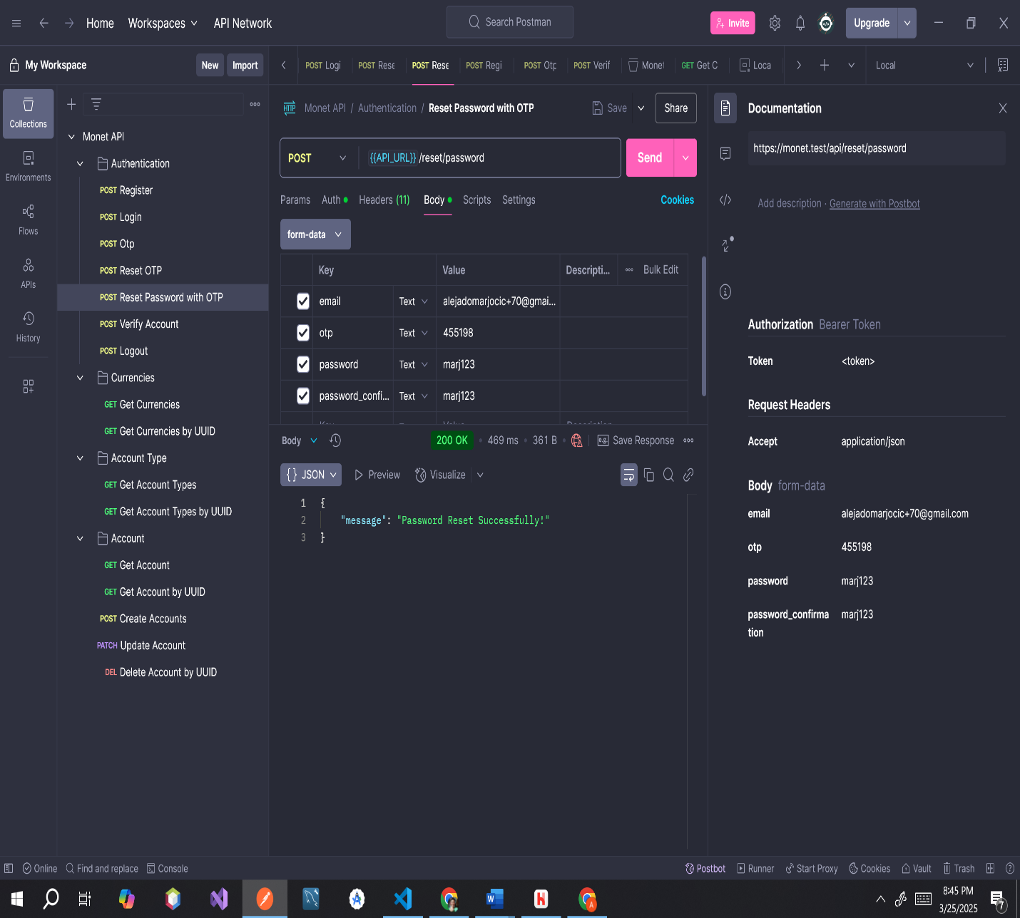

**ERROR MESSAGE**

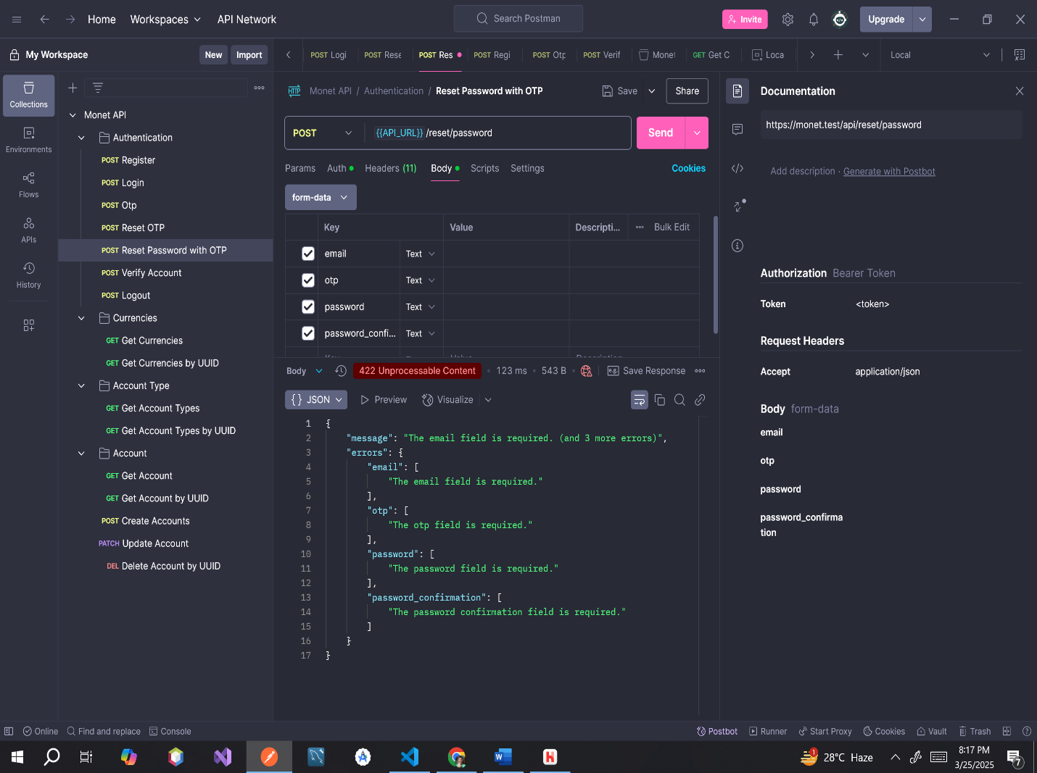

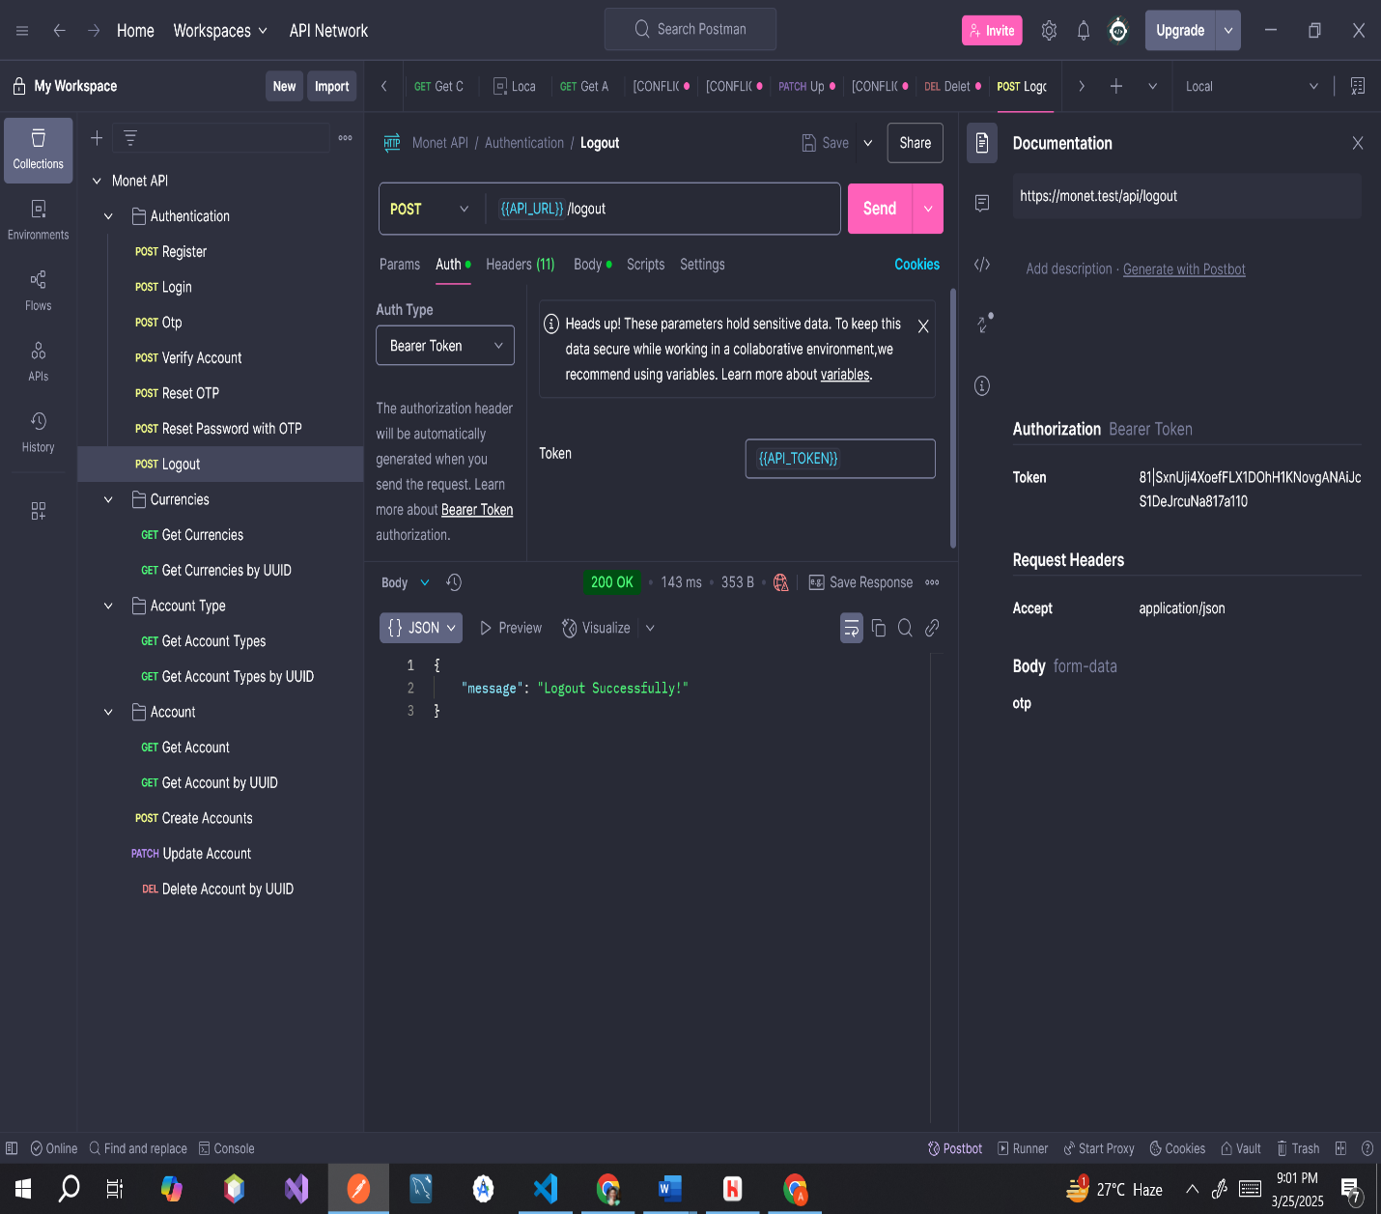**Endpoint:** [**https://monet.test/api/logout**](https://monet.test/api/logout)

**ERROR MESSAGE**

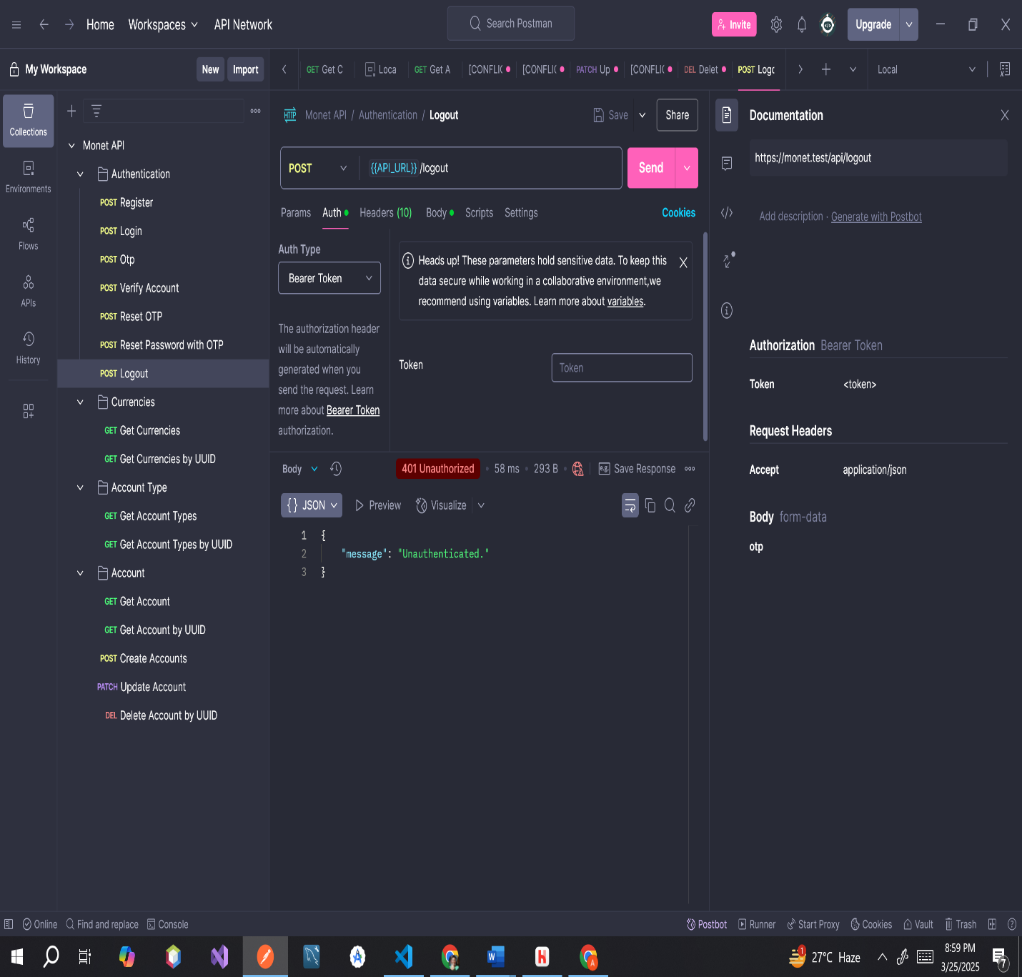

**CURRENCIES**

**Endpoint:** [**https://monet.test/api/currency**](https://monet.test/api/currency)

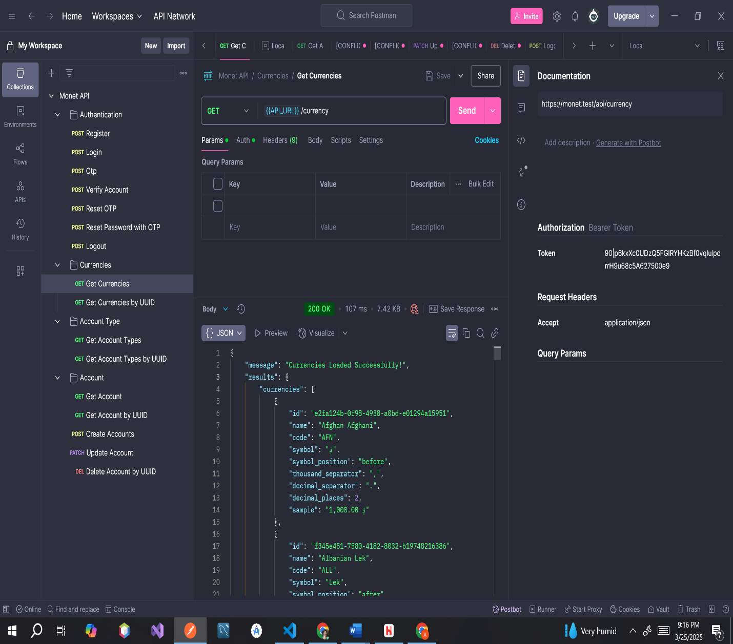

**ERROR MESSAGE**

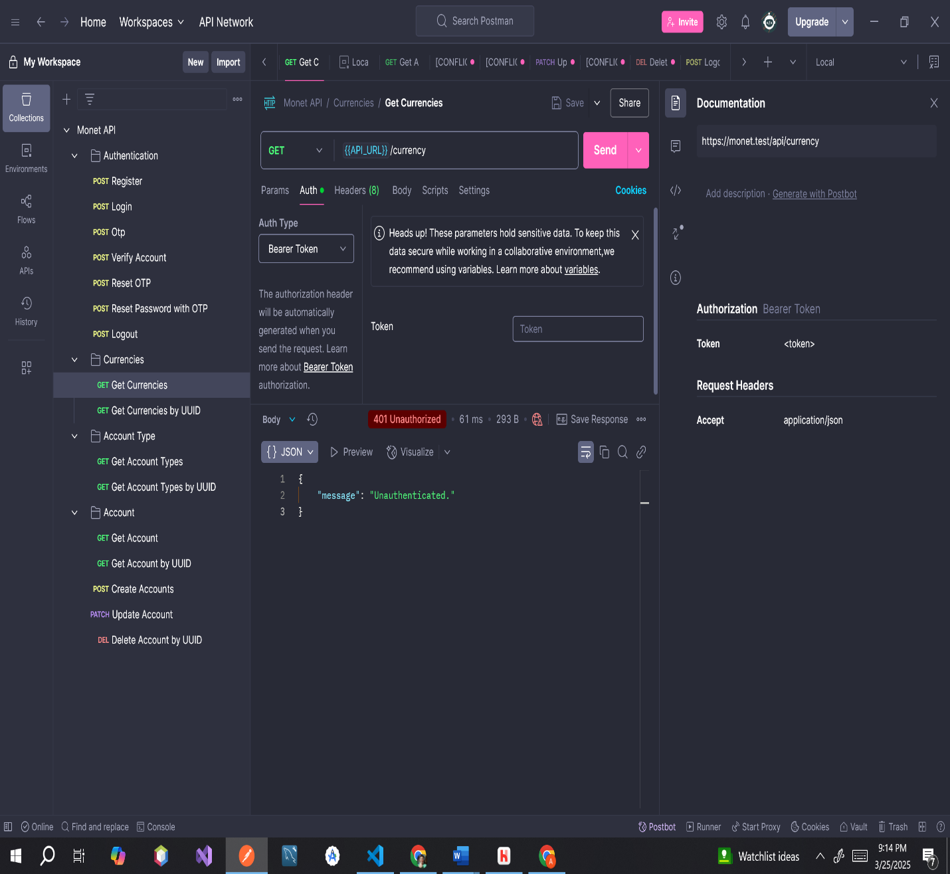

**Endpoint:** [**https://monet.test/api/currency/0e3f6798-e5ed-4cd4-b9a0-3976562712e7**](https://monet.test/api/currency/0e3f6798-e5ed-4cd4-b9a0-3976562712e7)

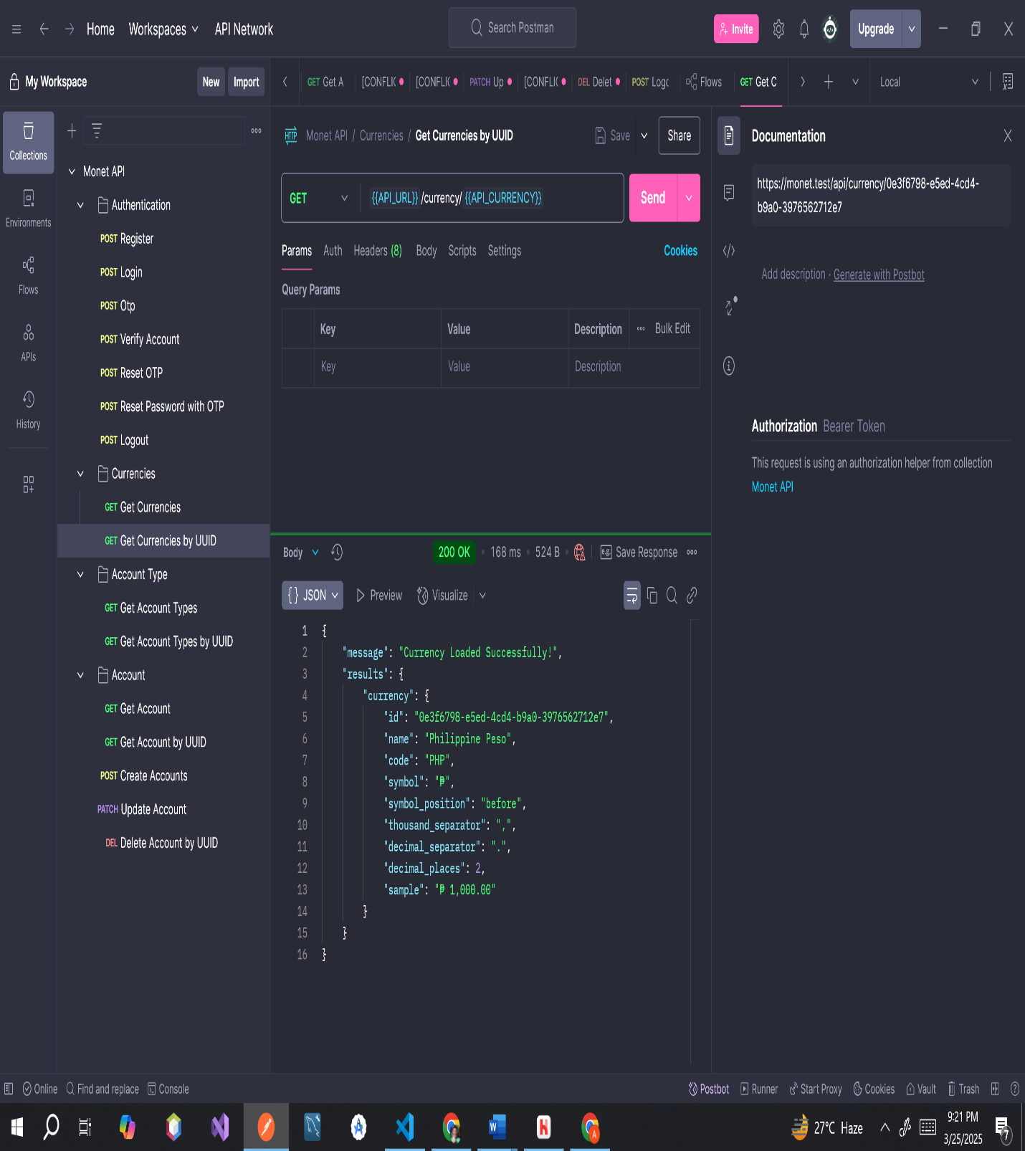

**ERROR MESSAGE**

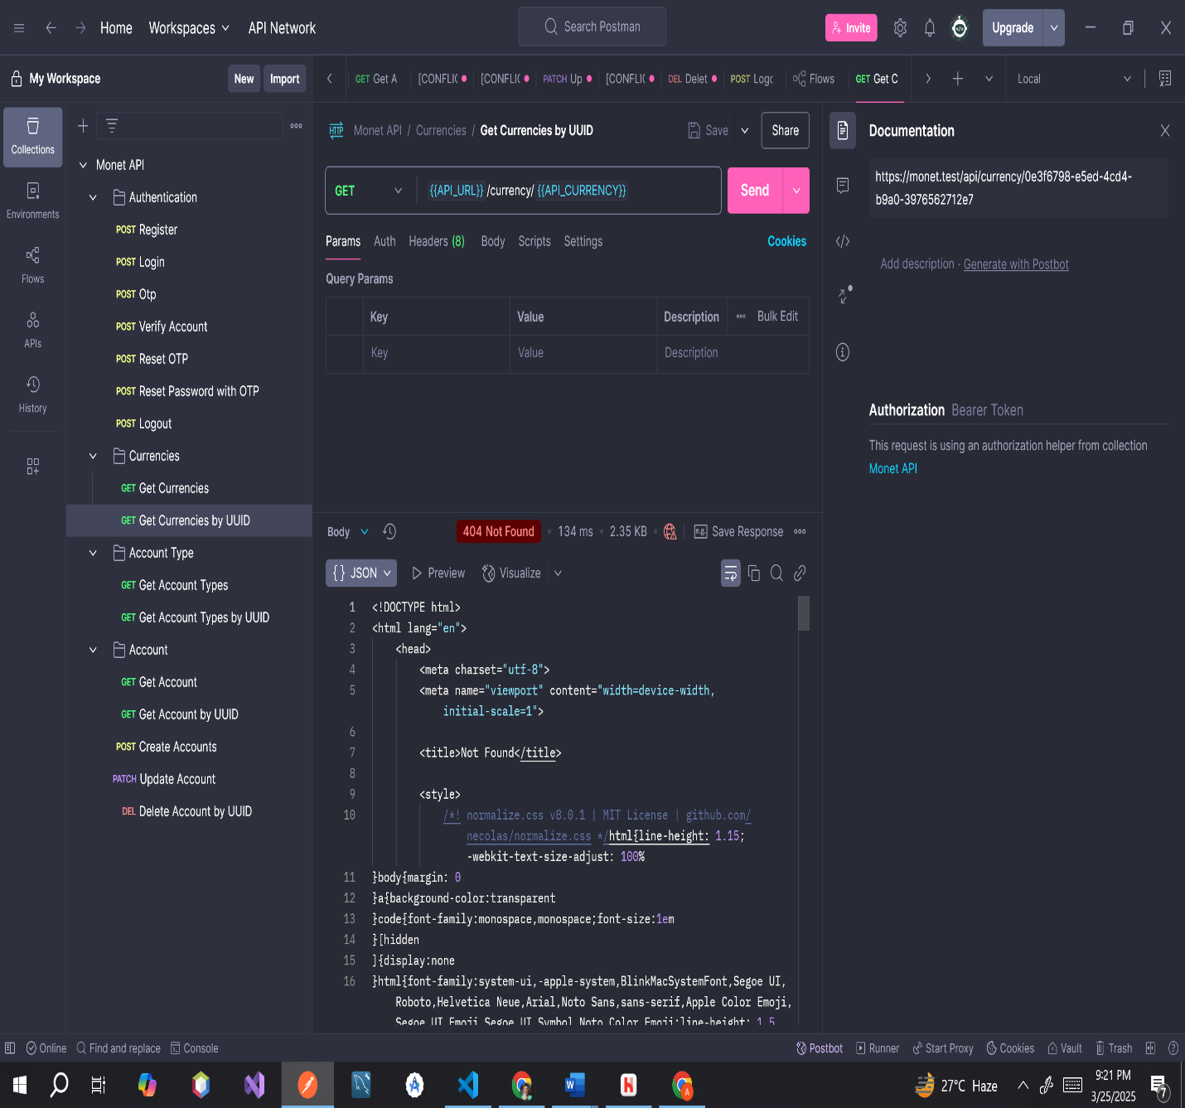

**Endpoint:** [**https://monet.test/api/account-type**](https://monet.test/api/account-type)

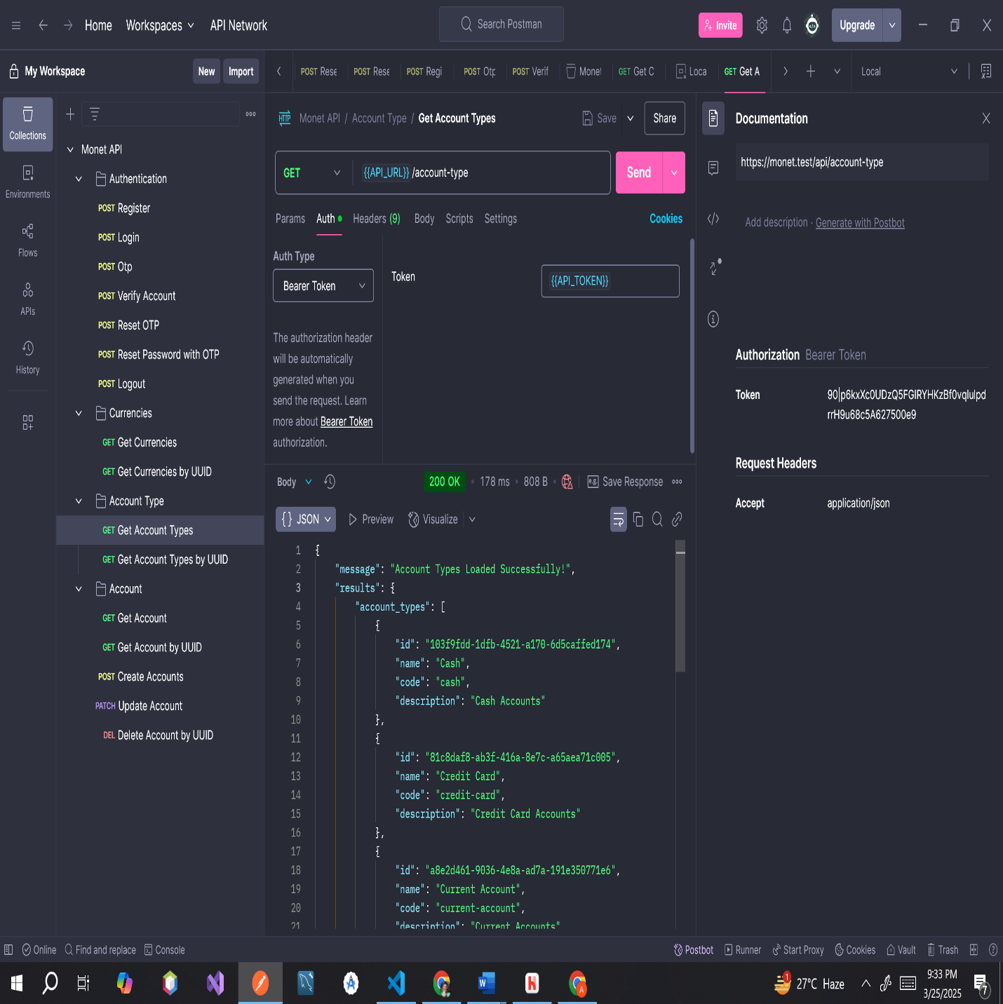

**ERROR MESSAGE**

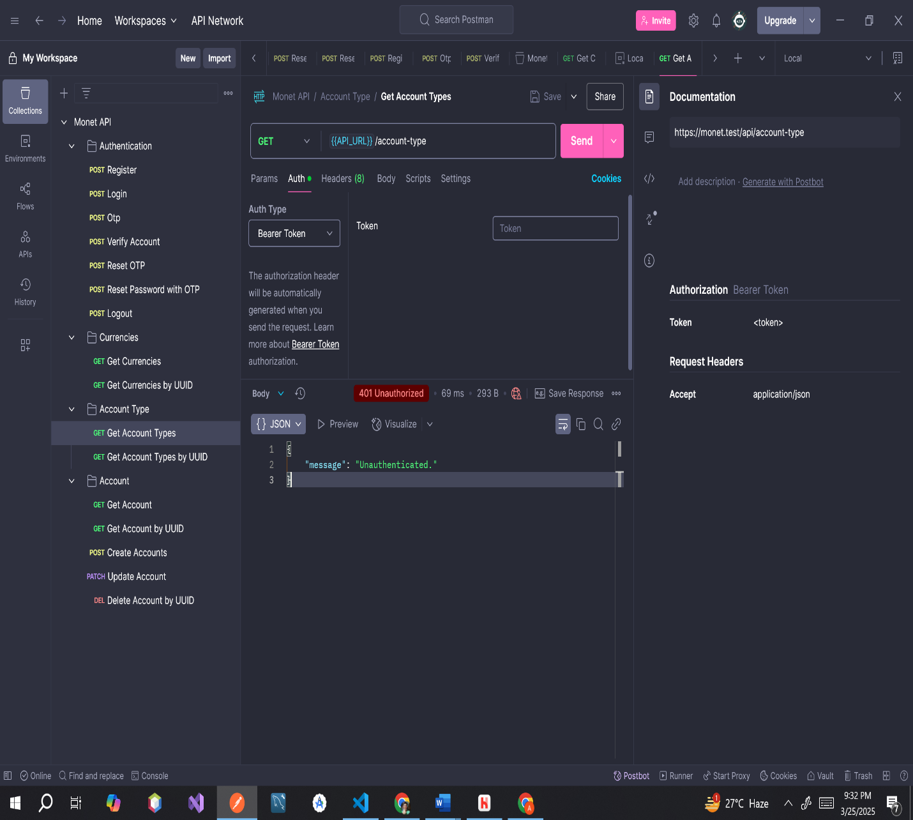

**Endpoint:** [**https://monet.test/api/account-type/2a12ba35-19d5-4669-88c3-74cfae0e6f4c**](https://monet.test/api/account-type/2a12ba35-19d5-4669-88c3-74cfae0e6f4c)

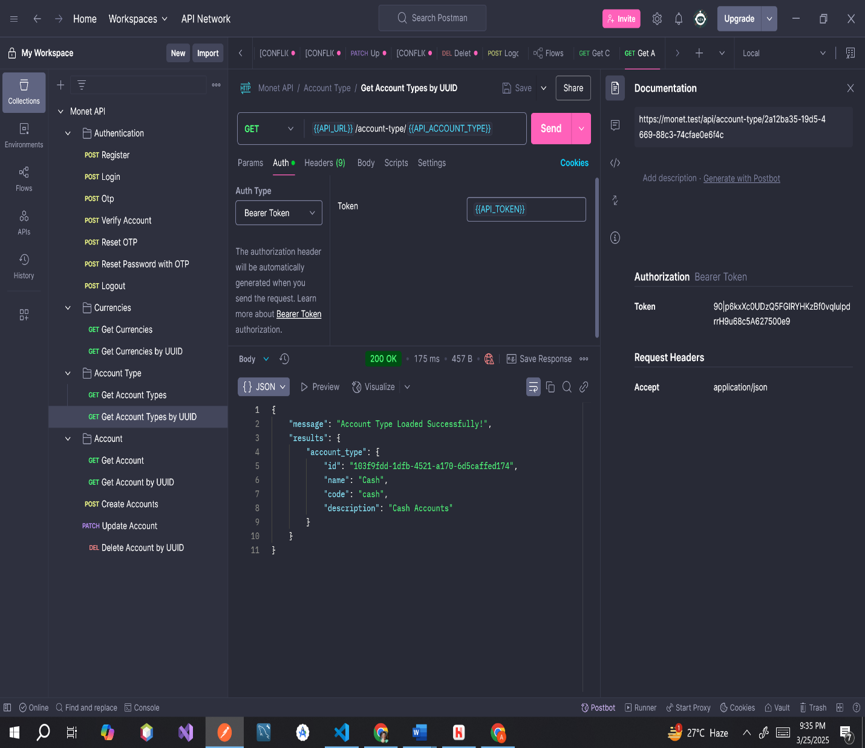

**ERROR MESSAGE**

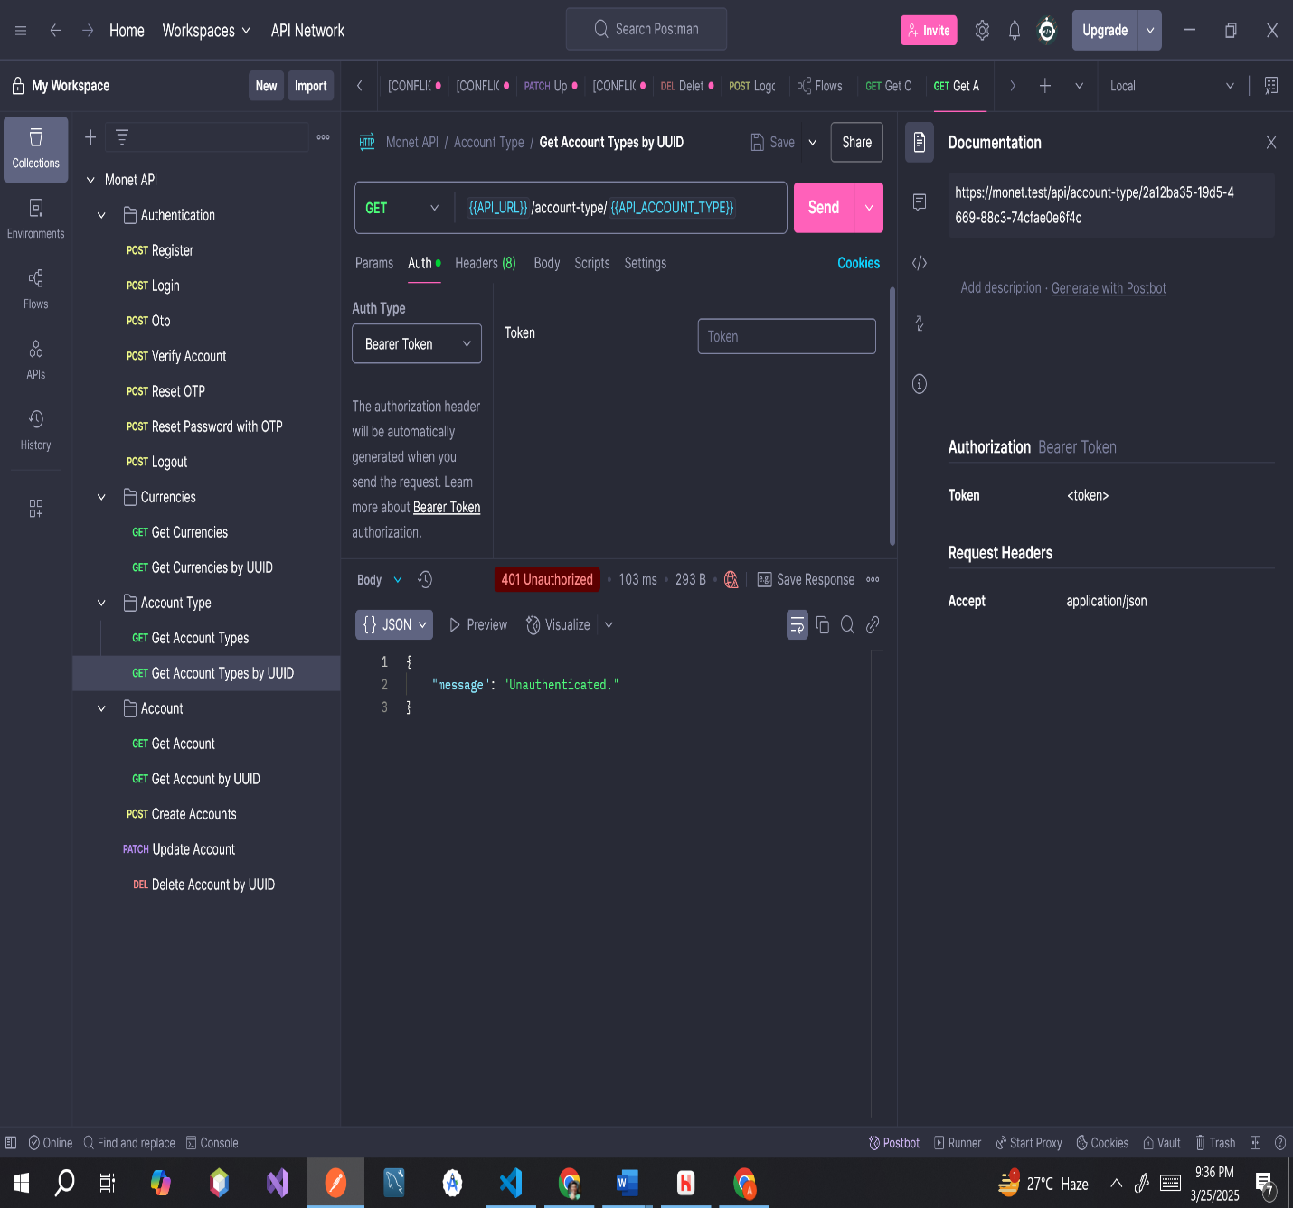

**ACCOUNTS**

**Endpoint:** [**https://monet.test/api/account**](https://monet.test/api/account)

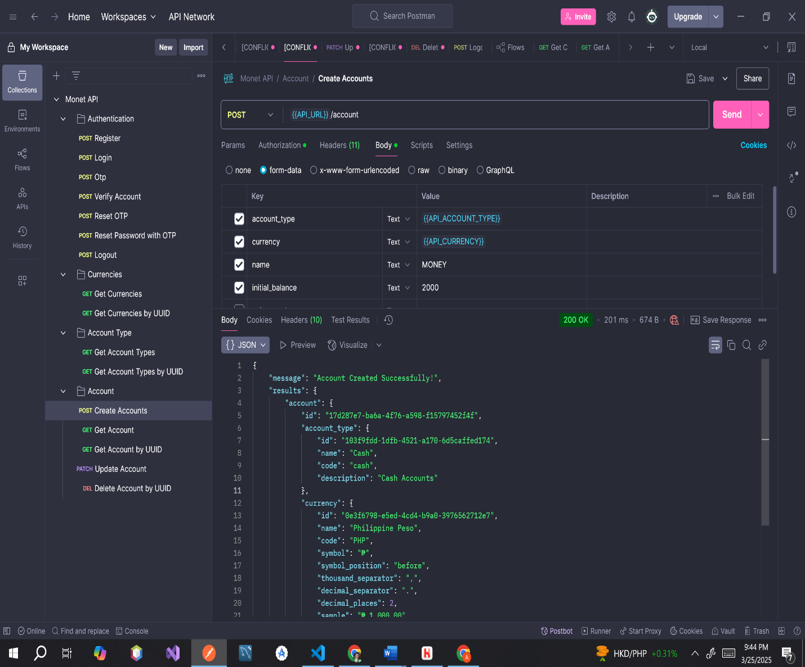

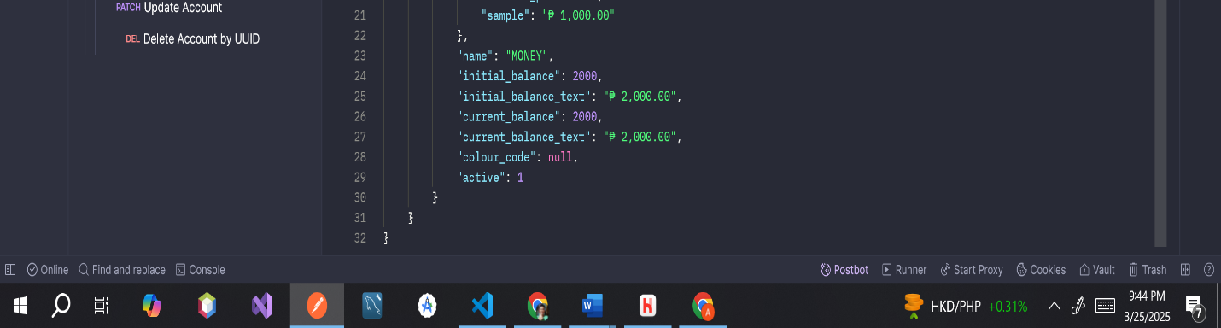

**ERROR MESSAGE**

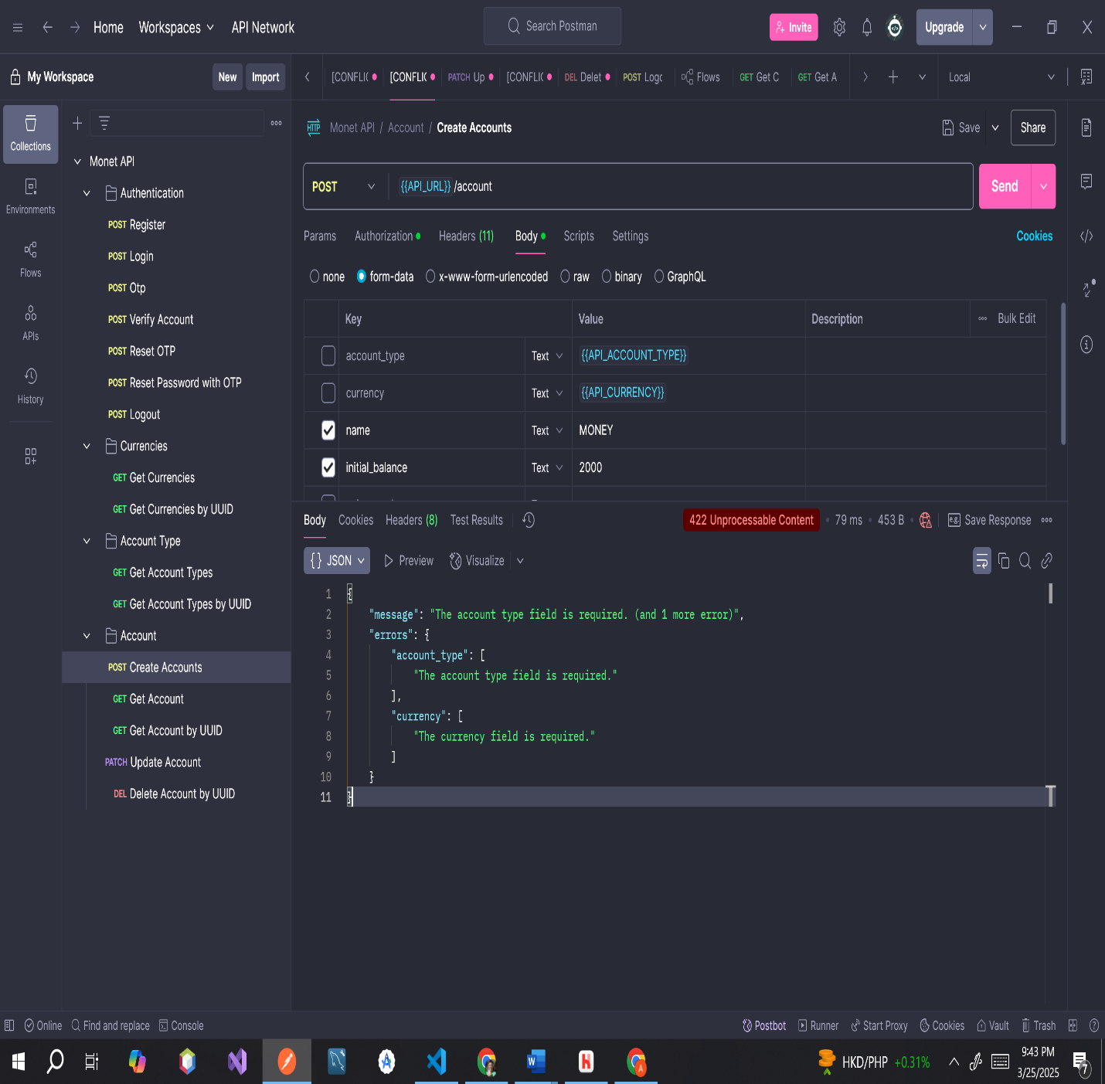

**Endpoint:** [**https://monet.test/api/account**](https://monet.test/api/account)

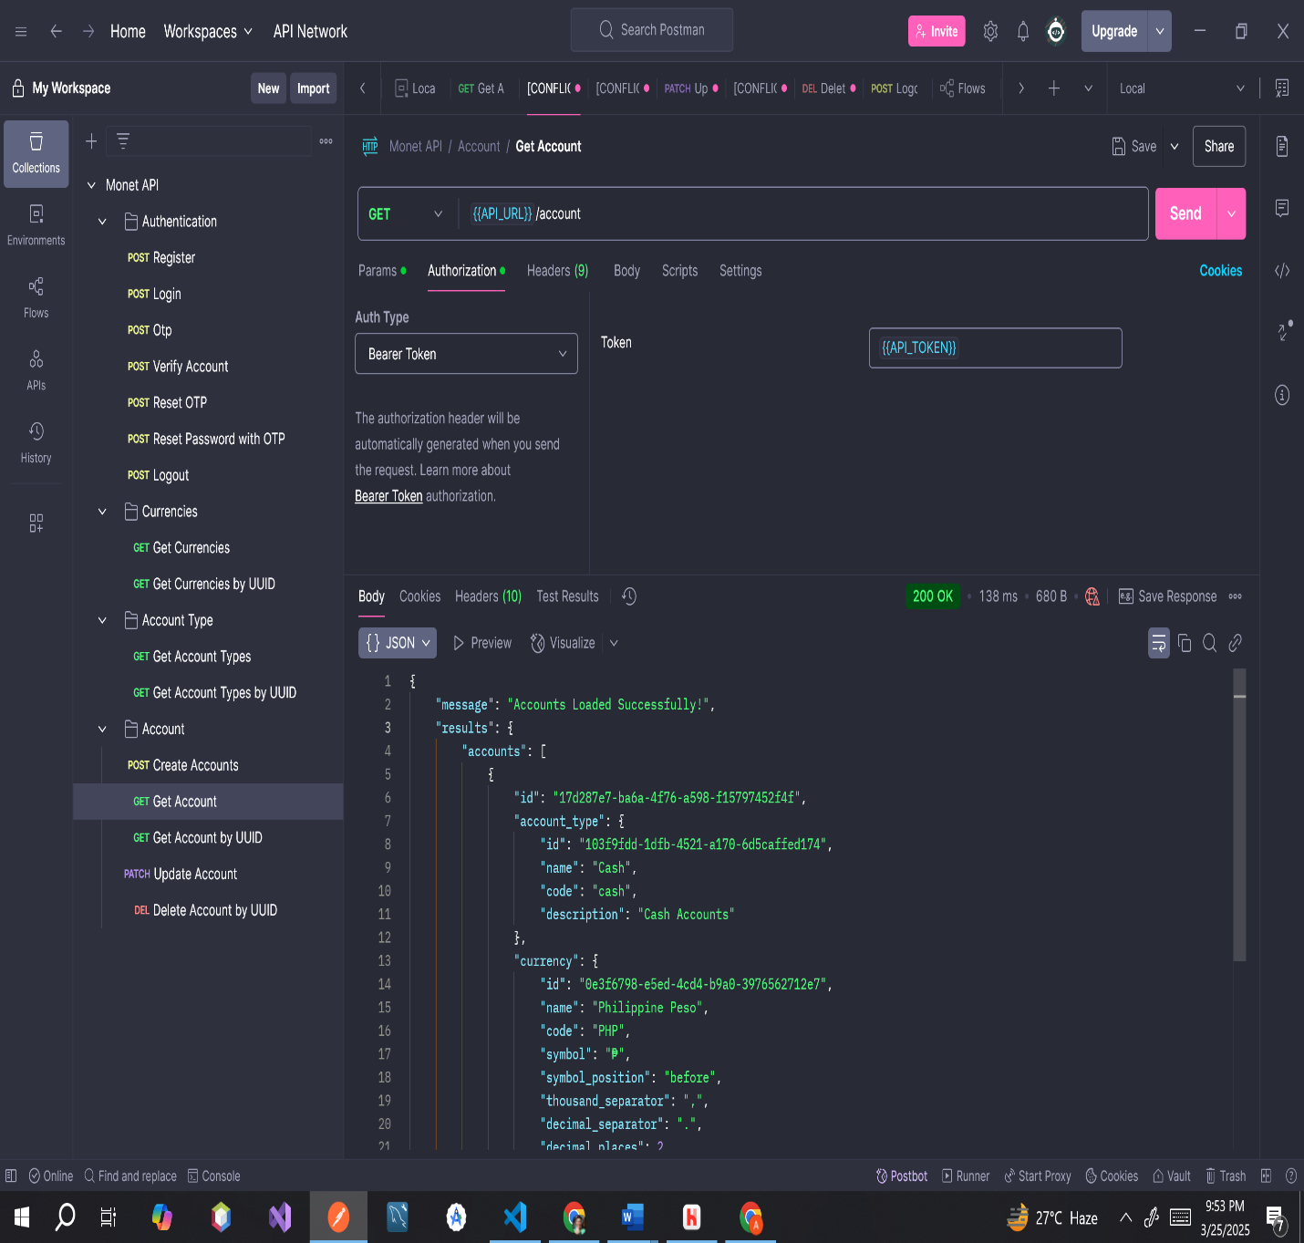

**ERROR MESSAGE**

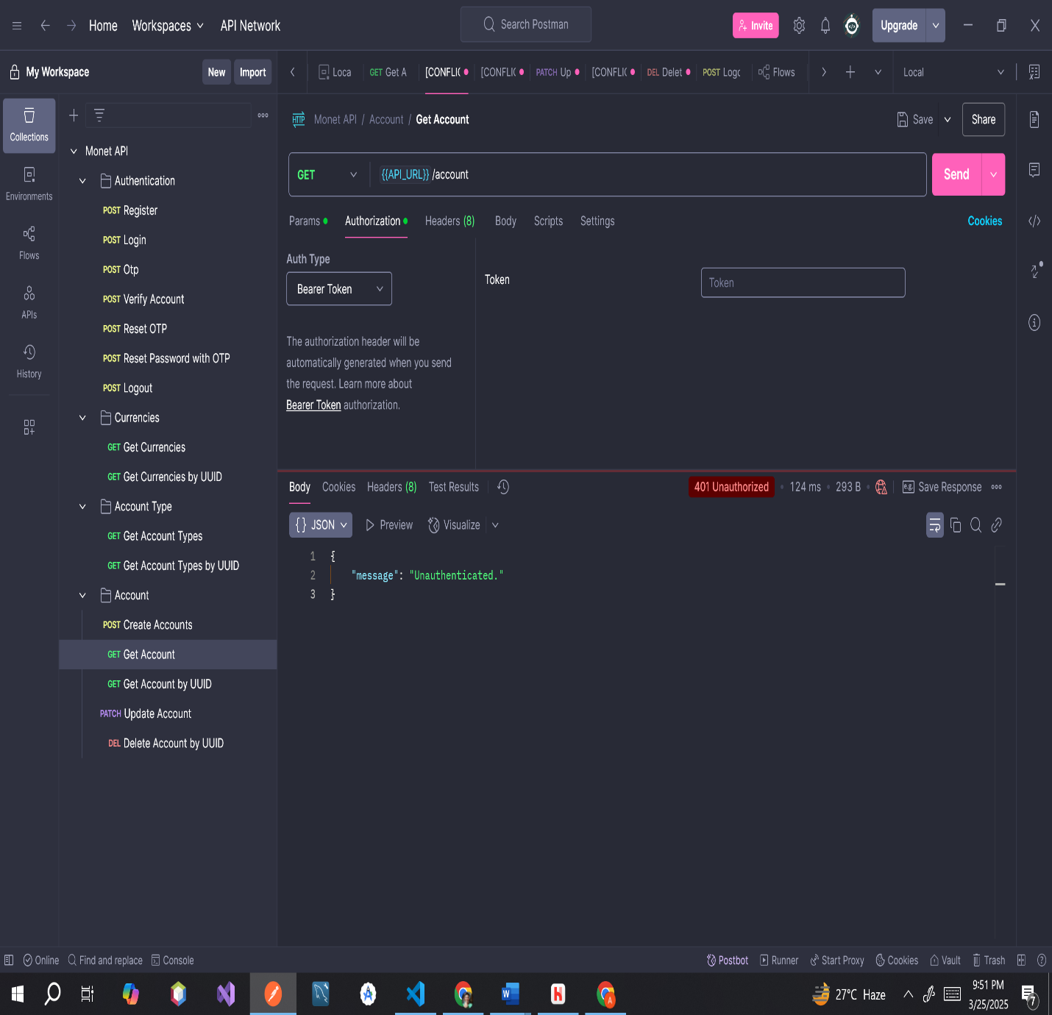

**Endpoint:** [**https://monet.test/api/account/17d287e7-ba6a-4f76-a598-f15797452f4f**](https://monet.test/api/account/17d287e7-ba6a-4f76-a598-f15797452f4f)

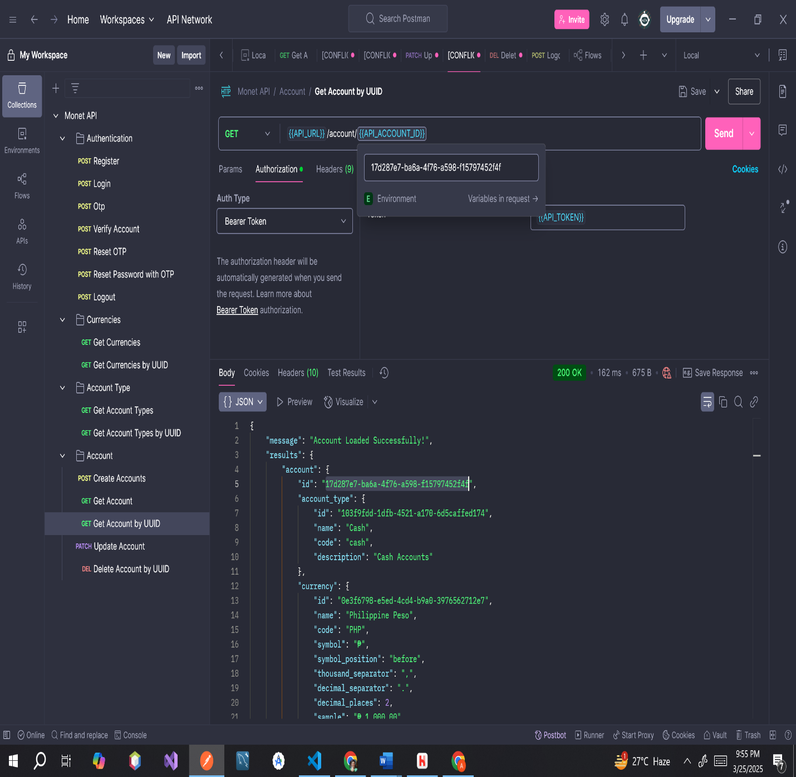

**ERROR MESSAGE**

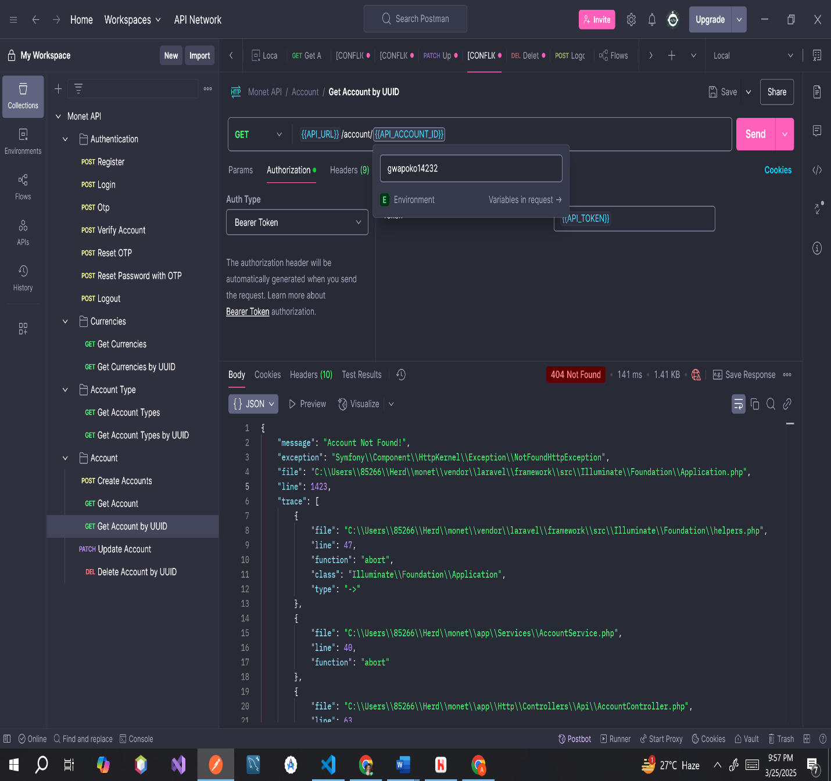

**Endpoint:** [**https://monet.test/api/account/17d287e7-ba6a-4f76-a598-f15797452f4f**](https://monet.test/api/account/17d287e7-ba6a-4f76-a598-f15797452f4f)

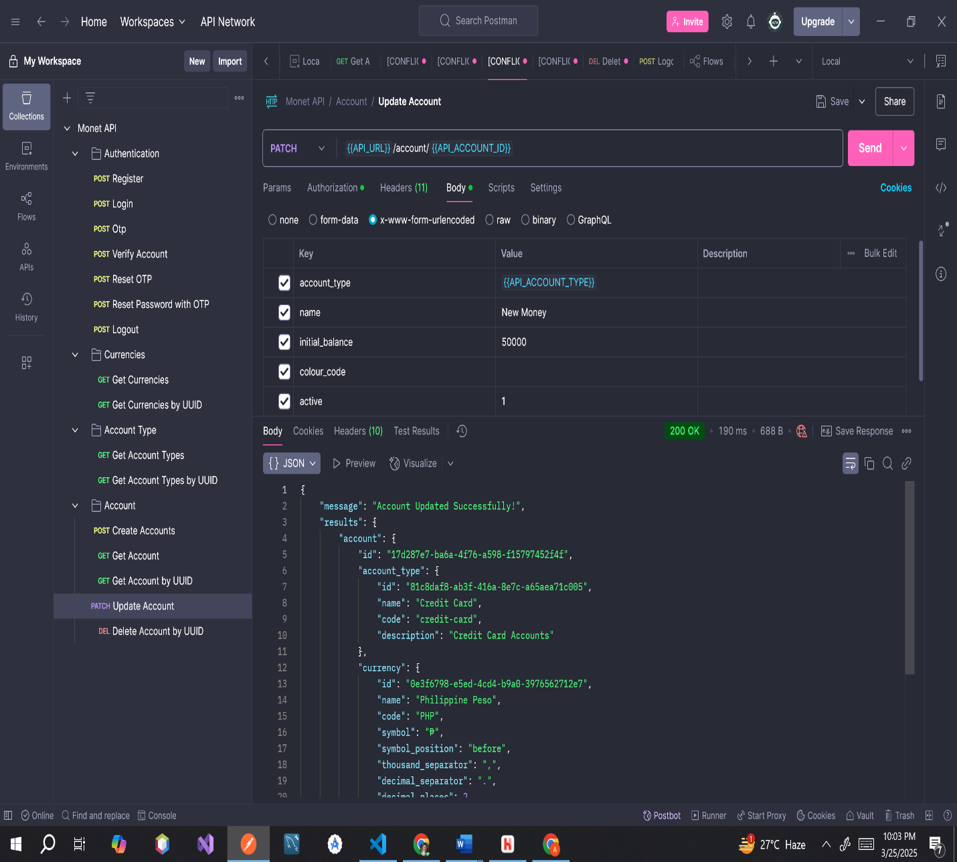

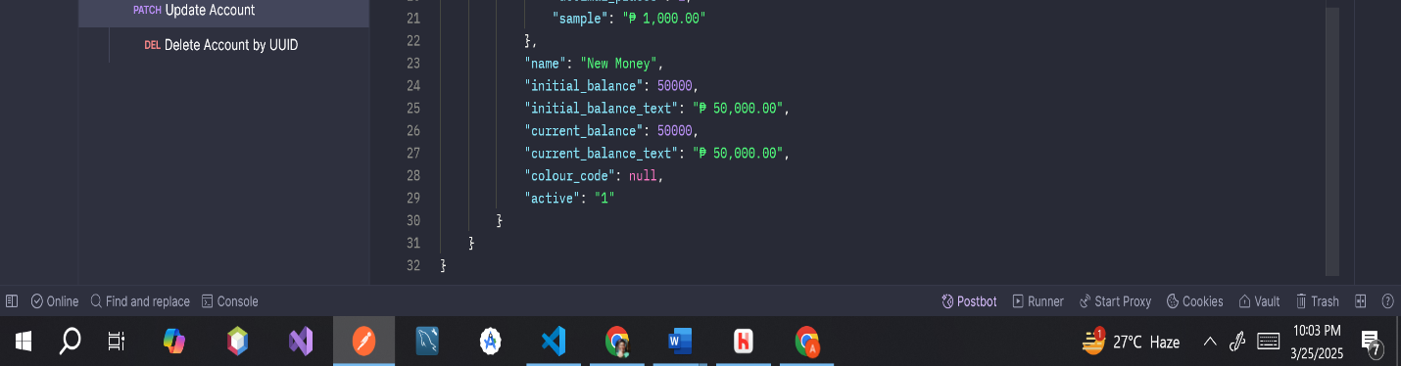

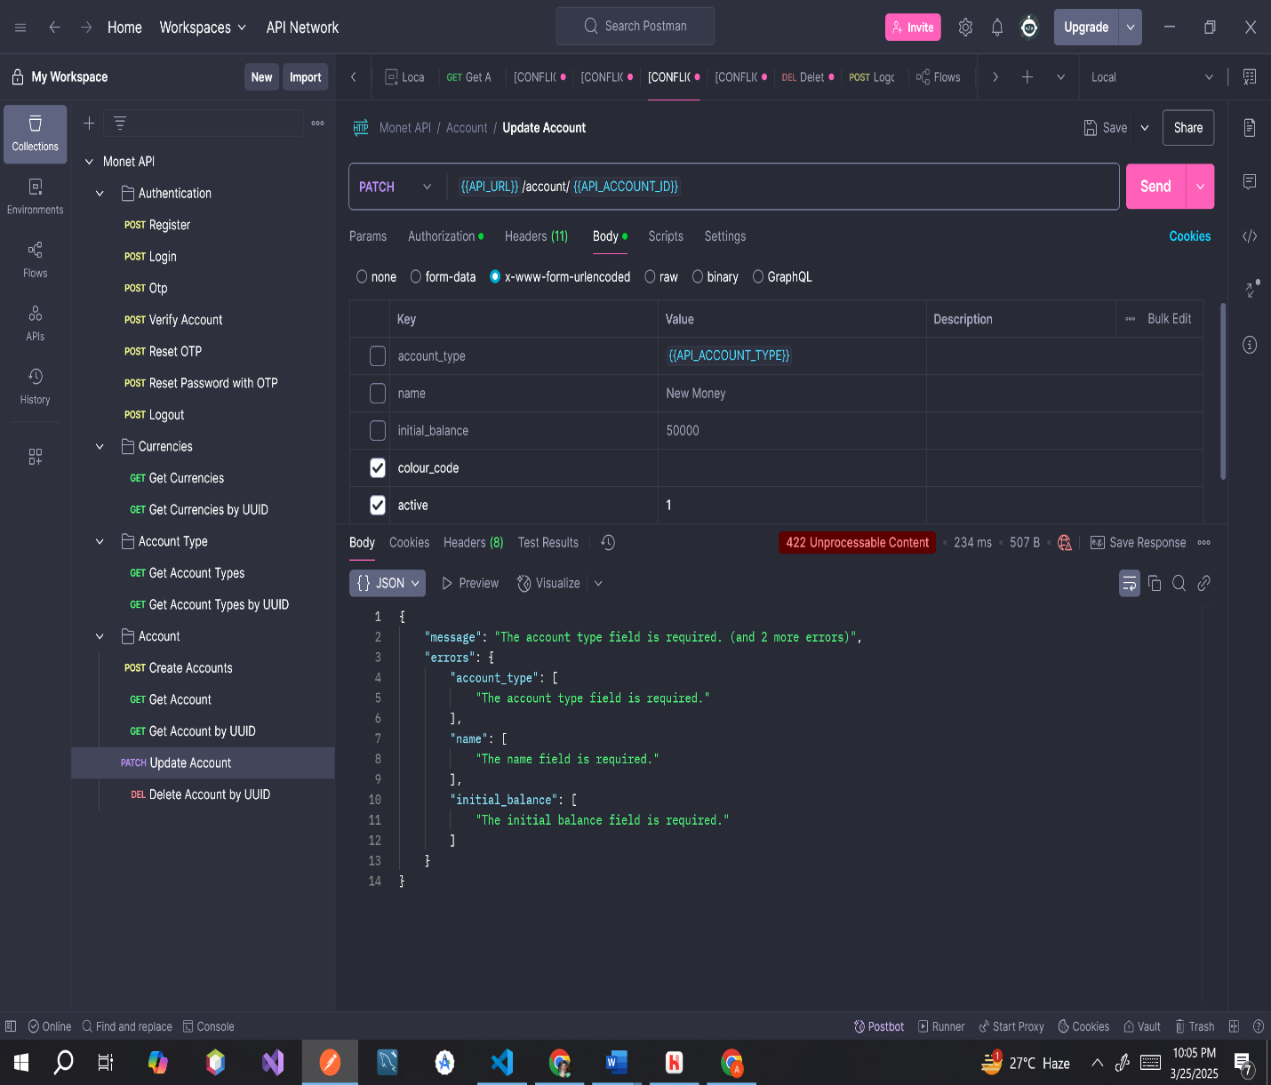**ERROR MESSAGE**

**Endpoint:** [**https://monet.test/api/account/17d287e7-ba6a-4f76-a598-f15797452f4f**](https://monet.test/api/account/17d287e7-ba6a-4f76-a598-f15797452f4f)

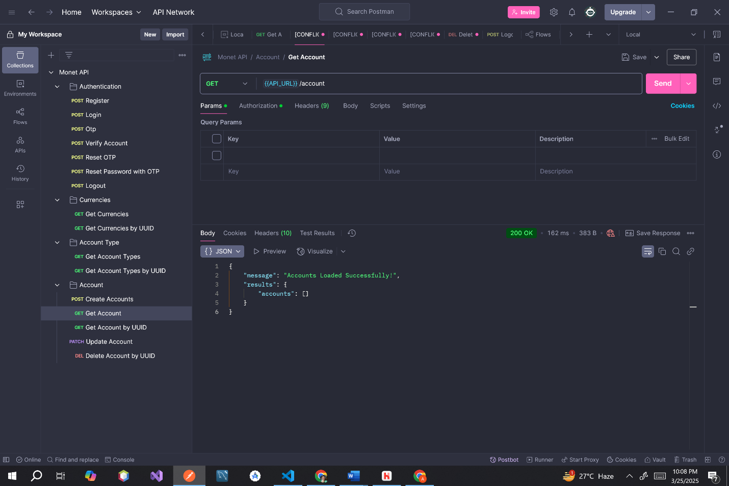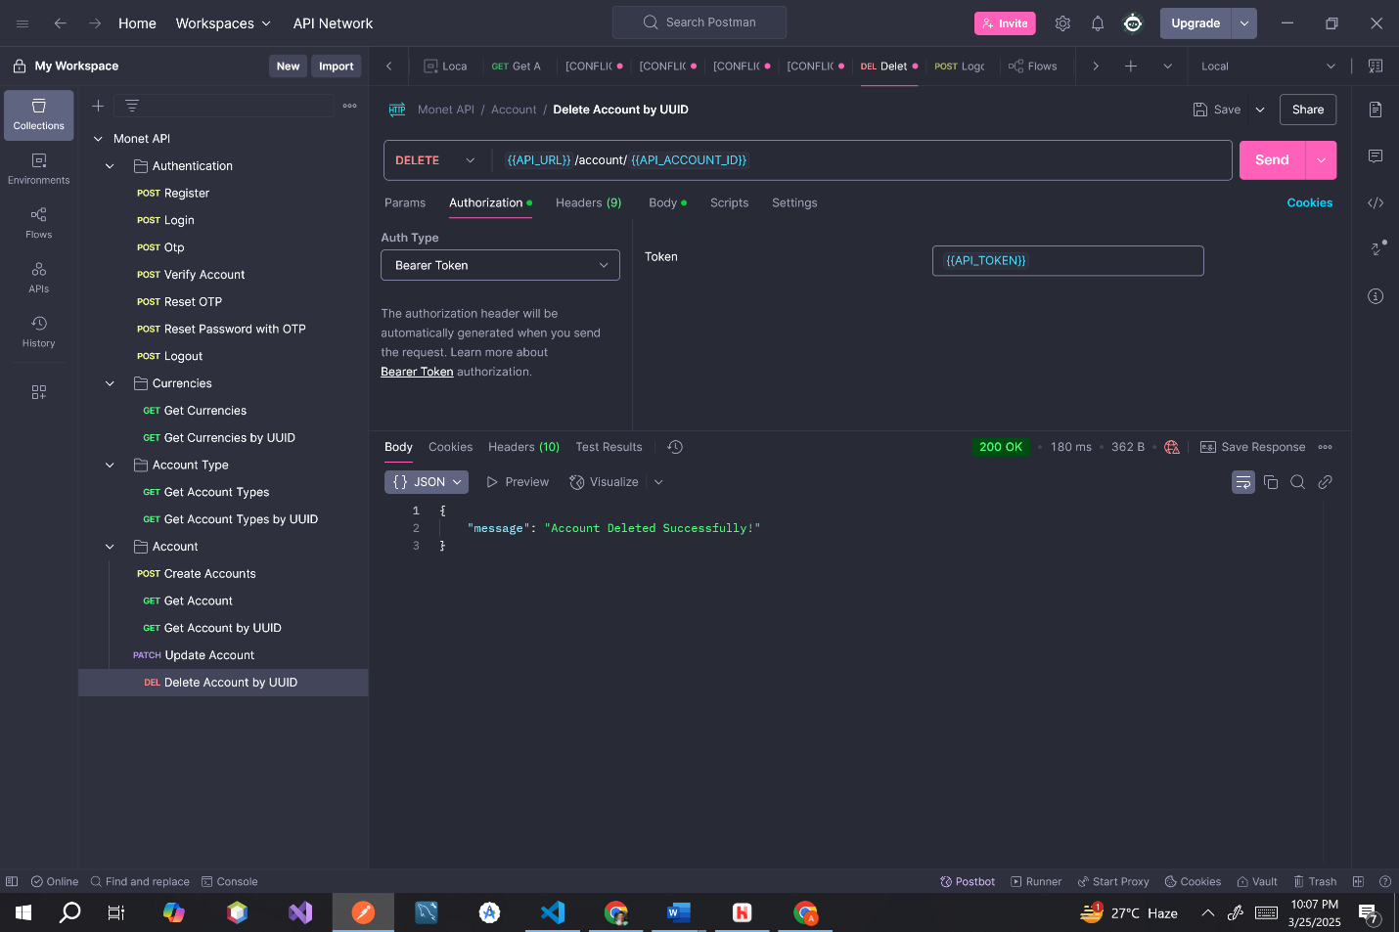**ERROR MESSAGE**

